VLSI PHYSICAL DESIGN Experiment Manual

OpenROAD

Marwadi University Information and communication Technology

VLSI PHYSICAL DESIGN OpenROAD Experiment Manual
Suggested List of Experiments:

Contents : Unit | Topics | Contact Hours
1 | Experiment-1 Explore the OpenROAD flow and develop the environment to use open source tools for RTL2GDS flow | 2
2 | Experiment-2 Perform RTL Synthesis of the design using yosys open synthesis tool. | 2
3 | Experiment-3 Develop the data base using OpenDB for physical chip design. | 2
4 | Experiment-4 Initialize the floor plan with necessary specifications. | 2
5 | Experiment-5 Develop power grid planning using PDNGEN | 2
6 | Experiment-6 Learn the pin placement using ioPlacer | 2
7 | Experiment-7 Place an IO ring around the boundary of a chip and connect with either wirebond pads or a bump array | 2
8 | Experiment-8 Explore OpenSTA as a gate level static timing verifier and as a stand-alone executable to verify the timing of a design using standard file format. | 2
9 | Experiment-9 Perform the detailed placement analysis using OpenDP | 2
10 | Experiment-10 Analyze clock tree synthesis using TritonCTS 2.0 | 2
11 | Experiment-11 Perform global routing using TritonRoute and do analysis of design. | 2
12 | Experiment-12 Do IR drop analysis using PDNSim | 2
13 | Experiment-13 Perform parasitic extraction analysis using OpenRCX | 2
14 | Experiment-14 Check antenna rules violations using Antenna Rule Checker and generate a report. | 2
 | Total Hours | 28

EXPERIMENT–1

Title:
Explore the OpenROAD Flow and Develop the Environment to Use Open-Source Tools for RTL-to-GDSII Flow Contact Hours: 2 Hours

AIM
To explore the OpenROAD RTL-to-GDSII flow and set up a working environment using open-source EDA tools for digital physical design.

OBJECTIVES
After completing this experiment, the student will be able to:
- Understand the complete RTL-to-GDSII physical design flow.
- Understand the role of OpenROAD and OpenROAD-flow-scripts.
- Set up the OpenROAD environment in Linux.
- Verify the installation of OpenROAD and supporting tools.
- Understand the input and output files used at different stages.
- Execute a sample design through the OpenROAD flow.
- Observe generated reports and physical-design results.
OpenROAD provides an open-source digital place-and-route environment, while OpenROAD-flow-scripts provides a ready-to-use RTL-to-GDSII flow controlle

SOFTWARE / TOOLS REQUIRED

S.No. | Software / Tool | Purpose
1  2  3  4  5  6  7  8 | Ubuntu/Linux | Operating environment
1  2  3  4  5  6  7  8 | OpenROAD | Physical design implementation
1  2  3  4  5  6  7  8 | OpenROAD-flow-scripts | RTL-to-GDSII flow
1  2  3  4  5  6  7  8 | Yosys | RTL synthesis
1  2  3  4  5  6  7  8 | OpenSTA | Static timing analysis
1  2  3  4  5  6  7  8 | OpenDB | Physical design database
1  2  3  4  5  6  7  8 | Tcl | Flow scripting
1  2  3  4  5  6  7  8 | Nangate45 / SKY130 PDK | Technology information

S.No.  9 | Software / Tool | Purpose
S.No.  9 | Gvim | Editing configuration/Tcl files

OpenROAD supports Tcl-based flow control and provides commands for reading/writing LEF, DEF, Verilog and database files.

THEORY

Introduction to OpenROAD
OpenROAD is an open-source digital physical-design tool used to implement a digital circuit from synthesized RTL/netlist toward a manufacturable physical layout.
The major objective is to provide an integrated environment for the RTL-to-GDSII implementation flow. The simplified flow is:


OpenROAD documentation describes the flow as an RTL-to-GDSII implementation flow containing stages such as floorplanning, I/O placement, PDN creation, placement, CTS and routing.

OPENROAD FLOW COMPONENTS

Stage | Open-Source Tool / Module | Function
RTL Synthesis | Yosys | Converts RTL into gate-level netlist
Database | OpenDB | Stores design physical information
Floorplanning | OpenROAD/IFP | Creates die/core area
I/O Placement | ioPlacer/PPL | Places I/O pins
Power Planning | PDNGEN | Creates power distribution network
Global Placement | RePlAce/GPL | Determines approximate cell locations
Detailed Placement | OpenDP/DPL | Legalizes cell locations
CTS | TritonCTS | Builds clock tree
Global Routing | FastRoute/GRT | Generates global routing
Detailed Routing | TritonRoute/DRT | Performs detailed routing
Extraction | OpenRCX | Extracts parasitic R and C
Timing | OpenSTA | Performs static timing analysis
IR Drop | PDNSim | Performs power-grid analysis
Antenna | Antenna Checker | Checks antenna violations

RTL-TO-GDSII FILES
The important files used in the flow are:

File | Description
.v | Verilog RTL/netlist
.lib | Liberty timing library
.lef | Physical abstract information
.sdc | Timing constraints

File | Description
.def | Physical design information
.odb / .db | OpenDB design database
.spef | Extracted parasitic information
.gds | Final physical layout
.tcl | OpenROAD flow script
.rpt | Analysis/report file

- PROCEDURE
Step 1: Open the Linux Terminal Open the Ubuntu/Linux terminal. Check the current user:
Cd : whoami

Check the operating system:
Cd : uname -a

Check the current directory:
Cd : pwd

Step 2: Check OpenROAD Installation
Execute:
Cd : openroad -version

If OpenROAD is correctly installed, the command should display the installed version and available command-line options.
The official OpenROAD command-line interface supports options such as -help, -version, -gui, -threads, -log, and -db.
Link :https://openroad.readthedocs.io/en/latest/main/README2.html

CHECK OPENROAD INTERACTIVE MODE

Step 1: Start OpenROAD
From the Linux terminal, execute:
Cd: openroad

You should see:
OpenROAD 26Q2-1994-g065077a742
Features included (+) or not (-): +GPU +GUI +Python
openroad>

Step 2: Check Available Commands
Inside the OpenROAD interactive prompt, execute:
Cd :help
You can also check the available Tcl commands using:
Cd :info commands

Step 3: Check OpenROAD Version
Do not use version inside the OpenROAD prompt, because it is not a valid OpenROAD Tcl command.

Exit OpenROAD:
Cd : exit
Then, from the Linux terminal, execute:
Cd :openroad --version

Expected output:
OpenROAD 26Q2-1994-g065077a742

Step 4: Exit OpenROAD
Inside the OpenROAD prompt:
Cd :exit
You will return to the Linux terminal: karnati_kiran@KIRAN-MOHNS5RV:~$ Important Note
For the current OpenROAD version:

OpenROAD 26Q2-1994-g065077a742
the following command is NOT valid inside interactive mode:

version
Therefore, use:

Cd :openroad --version
from the Linux terminal to check the OpenROAD version.
- OPENROAD-FLOW-SCRIPTS
If OpenROAD-flow-scripts is already installed:
Cd : cd ~/OpenROAD-flow-scripts Check the contents:
Cd : ls
You should find directories such as:
- flow
- docs
- etc
- platforms
- scripts
Move to the flow directory:
Cd: cd flow
Check available designs:
Cd: ls designs

For example:
Cd: ls designs/nangate45
A sample design such as gcd may be available.
- CHECK THE SAMPLE DESIGN
Move into the sample design directory:
Cd: cd designs/nangate45/gcd Check the files:
Cd: ls
You may find a configuration file such as:
- config.mk

The exact designs and file names depend on the version of OpenROAD-flow-scripts installed.

RUN THE SAMPLE OPENROAD FLOW
Return to the flow directory:
Cd: cd ~/OpenROAD-flow-scripts/flow Run the design using its configuration:
Cd: make DESIGN_CONFIG=designs/nangate45/gcd/config.mk This launches the configured RTL-to-GDSII flow.
The flow generates intermediate files and reports for different stages.

OBSERVE THE FLOW DIRECTORIES
After running the flow, inspect:
Cd : ls
Important directories include:
- logs/
- reports/
- results/
- objects/
You can inspect them using: cd :
- ls logs/
- ls reports/
- ls results/
The exact directory contents vary with the flow version and configuration.

RUN OPENROAD GUI
Open the OpenROAD graphical interface using:
Cd : openroad -gui
The GUI can be used to inspect:
- Die area
- Core area
- Standard cells
- Macros
- I/O pins
- Placement

- Clock tree
- Routing
- Congestion
- Power network

BASIC OPENROAD TCL COMMANDS
Start OpenROAD:
Cd :openroad Read a LEF file:
Cd: read_lef <technology.lef> or path Read another LEF:
Cd: read_lef <standard_cell.lef> or path

Read Liberty:
Cd:read_liberty <standard_cell.lib> or path

Read Verilog:
Cd :read_verilog <design.v> or path

Link the design:
Cd: link_design <top_module>

Read timing constraints:
Cd: read_sdc <design.sdc> or path

Write the database:
Cd : write_db <design.odb> or path

Read the database:
Cd : read_db <design.odb> or path

Write DEF:
Cd : write_def <design.def> or path
These are standard OpenROAD database/file commands documented by the project.

IMPORTANT OPENROAD FLOW STAGES

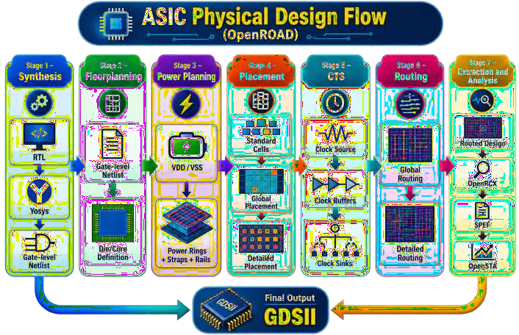

OBSERVATION TABLE

Parameter | Observation
OpenROAD Version
OS Version
PDK
Design Name
Top Module
Number of Instances
Number of Nets
Core Utilization
Die Area
Core Area
WNS
TNS
Routing Status
Final Output

18. RESULT

21. CONCLUSION

EXPERIMENT–2

Title
Perform RTL Synthesis of the Design Using Yosys Open Synthesis Tool Contact Hours: 2 Hours

AIM
To perform RTL synthesis of a digital design using the Yosys open-source synthesis tool and generate a ngate-level netlist suitable for further physical design implementation.

OBJECTIVES
After completing this experiment, the student will be able to:
- Understand the concept of RTL synthesis.
- Understand the role of Yosys in the RTL-to-GDSII flow.
- Read and elaborate Verilog RTL files using Yosys.
- Check the design hierarchy.
- Perform logic optimization.
- Perform technology mapping using a standard-cell library.
- Generate a synthesized gate-level Verilog netlist.
- Analyze synthesis statistics.

SOFTWARE / TOOLS REQUIRED

S.No. | Software / Tool | Purpose
1 | Ubuntu/Linux | Operating environment
2 | Yosys | RTL synthesis
3 | OpenROAD | Physical design
4 | GVim | RTL/script editing
5 | Liberty .lib | Standard-cell timing library
6 | Verilog .v | RTL source
7 | Tcl | Synthesis scripting

THEORY

RTL Synthesis
RTL synthesis is the process of converting a hardware description written at the Register Transfer Level (RTL) into a gate-level representation.
The basic process is:
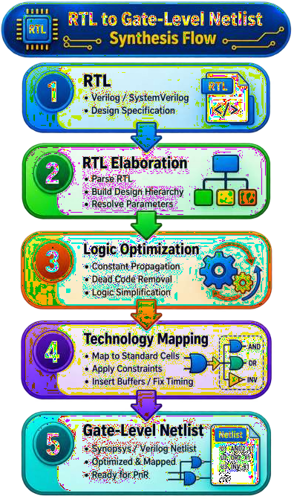

The synthesized netlist contains logic gates and sequential elements corresponding to the target standard-cell library.

Role of Yosys
Yosys is an open-source framework for RTL synthesis. It can:
    - Read Verilog/SystemVerilog RTL
    - Elaborate the design hierarchy
    - Convert processes into logic
    - Optimize Boolean logic
    - Infer flip-flops and memories
    - Perform technology mapping
    - Generate gate-level netlists
    - Generate synthesis statistics In an RTL-to-GDSII flow:
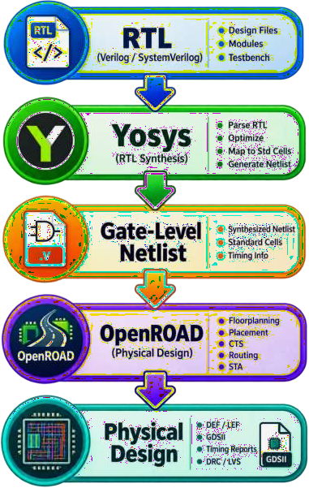

INPUT FILES
The following files are required.

RTL File
Example:

design.v
This contains the Verilog RTL description.

Liberty File
Example:
    - NangateOpenCellLibrary_typical.lib
The Liberty file contains information about:
      - Cell function
      - Timing
      - Power
      - Area
      - Input capacitance
      - Output characteristics

  - Optional Synthesis Script
Example:

    - synth.tcl

EXAMPLE RTL DESIGN
For this experiment, consider a simple 2-input AND circuit. Create the Verilog file:
- gvim and_gate.v
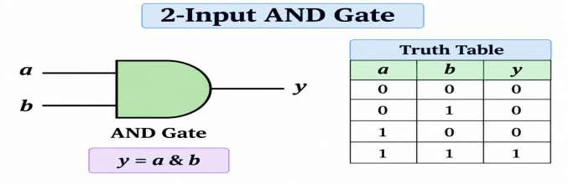

Enter:
module and_gate ( input a,
input b, output y
);
assign y = a & b; endmodule
Save and exit GVim.

PROCEDURE

Step 1: Check Yosys Installation
Open the terminal and execute:

cd: yosys -Version
The installed Yosys version should be displayed. You can also execute:
- cd: yosys -help
Step 2: Create a Working Directory
- Cd: mkdir -p ~/yosys_exp2
Move into the directory:
- Cd: cd ~/yosys_exp2 Check the current directory:

Cd: pwd
Step 3: Create the RTL File
Create the Verilog file:
- gvim and_gate.v
Enter:
module and_gate ( input a,
input b, output y
);

assign y = a & b; endmodule Save the file.

Check it:
- Cd :cat and_gate.v

START YOSYS
Run:
- Cd: yosys
The Yosys prompt will appear:

- yosys>

READ THE RTL FILE
Inside Yosys:

- read_verilog and_gate.v or path

This reads the Verilog RTL into Yosys.

CHECK DESIGN HIERARCHY
Execute:
- cd :hierarchy -check -top and_gate The -top option specifies the top-level module.
The hierarchy check verifies that the design hierarchy is valid.

DISPLAY THE DESIGN
Execute:

cd:stat
This displays synthesis-related statistics. For example:
- Number of wires
- Number of wire bits
- Number of cells
- Number of processes

PERFORM RTL SYNTHESIS
Execute:

- Cd :synth -top and_gate

The synth command performs the main synthesis process. The synthesis process includes operations such as:
RTL elaboration
↓
Process conversion
↓
Logic optimization
↓
Technology mapping

VIEW SYNTHESIS STATISTICS
After synthesis:
stat
Observe:
- Number of wires
- Number of cells
- Cell types
- Number of inputs
- Number of outputs

TECHNOLOGY MAPPING
For technology mapping, a Liberty standard-cell library can be provided. First read the Liberty file:
- Cd:read_liberty -lib <standard_cell.lib>

Then perform technology mapping:

- Cd:abc -liberty <standard_cell.lib>

Run:

- Cd:stat

again to observe the mapped cells.

Note: Replace <standard_cell.lib> with the actual Liberty file available in your PDK.

GENERATE THE GATE-LEVEL NETLIST
After synthesis, write the output netlist:
- Cd write_verilog -noattr synthesized_netlist.v
Check the generated file:
- Cd:ls
You should see:
- and_gate.v
- synthesized_netlist.v
Display the synthesized netlist:
- cd:cat synthesized_netlist.v

COMPLETE YOSYS COMMAND SEQUENCE
The complete basic sequence is:
- read_verilog and_gate.v
- hierarchy -check -top and_gate
- stat
- synth -top and_gate
- stat
- write_verilog -noattr synthesized_netlist.v For technology mapping:
- read_verilog and_gate.v
- hierarchy -check -top and_gate
- read_liberty -lib <standard_cell.lib>
- synth -top and_gate
- abc -liberty <standard_cell.lib>
- stat
- write_verilog -noattr synthesized_netlist.v Exit Yosys:
- exit

SYNTHESIS FLOW
- The experiment can be represented as:
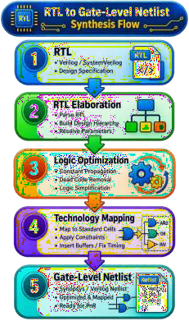

OBSERVATION TABLE
- Record the following values during the experiment:

Parameter | Observation
Yosys Version
RTL File
Top Module
Number of Inputs
Number of Outputs
Number of Wires
Number of Wire Bits
Number of Cells Before Mapping
Number of Cells After Mapping
Standard Cell Library

Parameter | Observation
Generated Netlist

- ANALYSIS

- EXPECTED OUTPUT

- RESULT

- CONCLUSION

EXPERIMENT–3
Title
Develop the Database Using OpenDB for Physical Chip Design Contact Hours: 2 Hours

AIM
To develop and initialize a physical design database using OpenDB and understand how design, technology, library, placement, routing, and connectivity information are stored for physical chip design.

OBJECTIVES
After completing this experiment, the student will be able to:
- Understand the concept of a physical design database.
- Understand the role of OpenDB in the OpenROAD flow.
- Read technology and standard-cell LEF files.
- Read the synthesized gate-level netlist.
- Link the design with the standard-cell library.
- Initialize the physical design database.
- Inspect design instances, nets, pins and technology information.
- Save and reload the OpenDB database.

SOFTWARE / TOOLS REQUIRED

S.No. | Software / Tool | Purpose
1 | Ubuntu/Linux | Operating environment
2 | OpenROAD | Physical design environment
3 | OpenDB | Physical design database
4 | Yosys | Synthesized netlist generation
5 | GVim | Editing Tcl/configuration files
6 | LEF | Physical library information
7 | Liberty | Timing/library information
8 | Verilog | Gate-level netlist

THEORY

Introduction to OpenDB
OpenDB is the physical design database used by OpenROAD.
It stores information required during different stages of physical implementation. The database contains information related to:
      - Technology
      - Standard-cell libraries
      - Design blocks
      - Instances
      - Nets
      - Pins
      - Ports
      - Die area
      - Core area
      - Placement rows
      - Routing layers
      - Physical shapes
      - Placement
      - Routing
OpenDB provides the common database infrastructure that allows different OpenROAD engines to operate on the same design representation.
Link:https://openroad.readthedocs.io/en/latest/main/src/odb/README.html

ROLE OF OPENDB IN OPENROAD
The OpenROAD physical-design flow can be represented as:
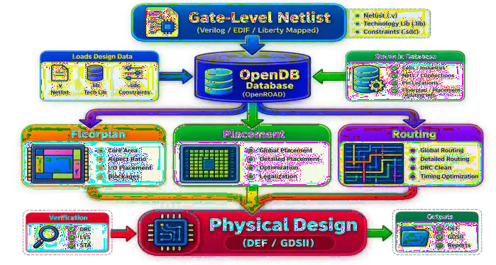

IMPORTANT INPUT FILES

LEF File
LEF – Library Exchange Format
LEF contains the physical abstract information of technology and cells. It may contain:
      - Metal layers
      - Via information
      - Cell dimensions
      - Cell pins
      - Pin layers
      - Routing directions
      - Placement sites Example:
      - technology.lef and
      - standard_cell.lef

Liberty File
The Liberty file contains logical, timing and power information. Example:
      - standard_cell.lib

Verilog Netlist
The synthesized gate-level Verilog netlist contains:
      - Cell instances
      - Nets
      - Connections
      - Inputs
      - Outputs Example:
      - synthesized_netlist.v

OPENDB DATABASE HIERARCHY
- A simplified OpenDB hierarchy is:

The Technology portion describes the process technology, while the Block contains the physical design being implemented.
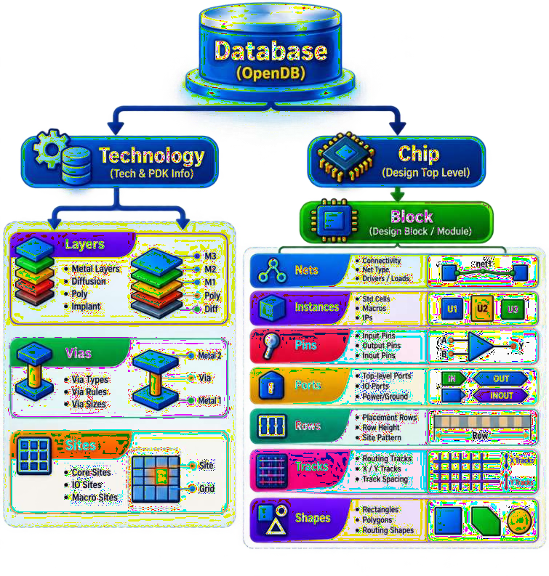

PROCEDURE

Step 1: Create a Working Directory
Open the terminal:
- Cd :mkdir -p ~/openroad_exp3 Move into the directory:
- Cd:cd ~/openroad_exp3 Check the current directory:
- Cd :pwd

STEP 2: CHECK OPENROAD
Execute:
- openroad -version
Start OpenROAD:
- openroad
You should see:
- OpenROAD>
Check the available commands:
- help

STEP 3: READ THE TECHNOLOGY LEF
Inside OpenROAD:
- read_lef <technology.lef> Example:
- read_lef /path/to/tech.lef
The technology LEF provides information about:
- Technology layers
- Routing layers
- Via definitions
- Manufacturing grid
- Routing rules

STEP 4: READ THE STANDARD-CELL LEF
Read the standard-cell LEF:
- read_lef <standard_cell.lef>
Example:
- read_lef /path/to/NangateOpenCellLibrary.lef
Now OpenROAD has the physical abstracts of the standard cells.

STEP 5: READ THE LIBERTY FILE
Read the timing library:
- read_liberty <standard_cell.lib> Example:
- read_liberty /path/to/NangateOpenCellLibrary.lib
The Liberty file allows OpenROAD to associate logical cell information with the physical cell information from LEF.

STEP 6: READ THE SYNTHESIZED NETLIST
Read the gate-level netlist generated in Experiment-2:
- read_verilog synthesized_netlist.v This loads:
- Instances
- Nets
- Ports
- Cell connections into the design.

STEP 7: LINK THE DESIGN
Specify the top-level module:
- link_design <TOP_MODULE> For example:
- link_design and_gate
The linking process connects the instances in the netlist to the corresponding library cells.

STEP 8: CHECK DESIGN INFORMATION
Run:
- report_design_area You can also use:
- report_floating_nets and:
- report_design_area
The reports help verify that the design has been correctly loaded.

STEP 9: INITIALIZE THE FLOORPLAN
To create the initial physical database, initialize the floorplan. Example:
- initialize_floorplan \
- -utilization 60 \
- -aspect_ratio 1.0 \
- -core_space 10 \
- -site <SITE>
For example, if the standard-cell site is:
- FreePDK45_38x28Site the command becomes:
- initialize_floorplan \
- -utilization 60 \
- -aspect_ratio 1.0 \
- -core_space 10 \
- -site FreePDK45_38x28Site
Note: The site name is technology-dependent. Use the site defined in your selected LEF.

STEP 10: CREATE ROUTING TRACKS
After floorplan initialization:
- make_tracks
This creates routing tracks according to the technology information. The database now contains important physical information such as:
- Die
- Core
- Rows
- Sites
- Routing tracks

STEP 11: SAVE THE DATABASE
Save the OpenDB database:
- write_db design.odb
The generated file is:
- design.odb
Check it from Linux:
- ls -lh design.odb

STEP 12: SAVE THE DESIGN AS DEF
The database can also be written as a DEF file:
- write_def design.def

Check:
- ls -lh design.def
Now the working directory may contain:
- design.odb
- design.def
- synthesized_netlist.v

STEP 13: READ THE DATABASE AGAIN
Exit OpenROAD:
- exit
Start OpenROAD again:
- openroad
Read the saved database:
- read_db design.odb
Check the design:
- report_design_area
This demonstrates that the physical design information has been stored in the OpenDB database and can be restored.

COMPLETE COMMAND SEQUENCE
The complete experiment can be performed using:
- read_lef <technology.lef>
- read_lef <standard_cell.lef>
- read_liberty <standard_cell.lib>

- read_verilog synthesized_netlist.v

- link_design <TOP_MODULE>

- report_design_area

- initialize_floorplan \
- -utilization 60 \
- -aspect_ratio 1.0 \
- -core_space 10 \
- -site <SITE>
- make_tracks

- write_db design.odb
- write_def design.def

DATABASE GENERATION FLOW
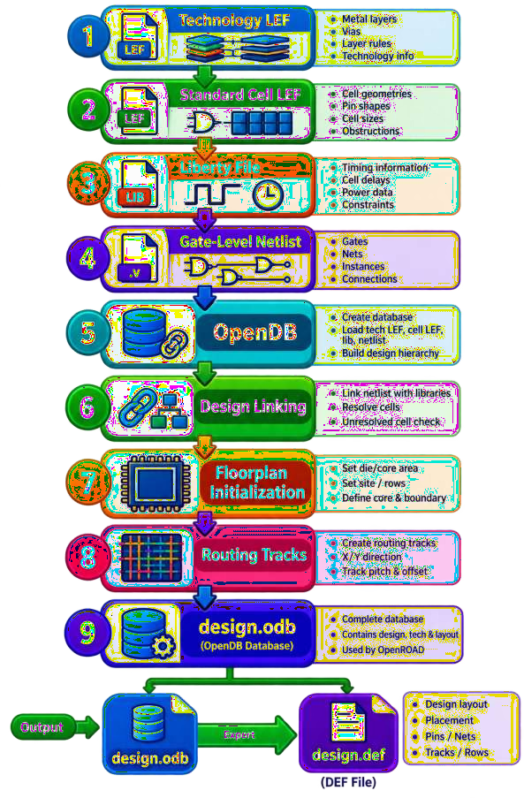

OBSERVATION TABLE

Parameter | Observation
OpenROAD Version
Technology
Technology LEF
Standard Cell LEF
Liberty File
Netlist File
Top Module
Number of Instances
Number of Nets
Number of Pins
Die Area
Core Area
Utilization
Aspect Ratio
Site Name
OpenDB File
DEF File

EXPECTED OUTPUT
After successful execution, the following files should be generated:
- design.odb
- design.def

ANALYSIS

  - RESULT

- CONCLUSION

EXPERIMENT– 4
Title
Initialize the Floor Plan with Necessary Specifications Contact Hours: 2 Hours

AIM
To initialize the floor plan of a digital chip design using OpenROAD by defining the die area, core area, utilization, aspect ratio, placement rows, and routing tracks.

OBJECTIVES
After completing this experiment, the student will be able to:
- Understand the concept of chip floorplanning.
- Understand the difference between die area and core area.
- Define the required core utilization.
- Set the aspect ratio of the floorplan.
- Create placement rows for standard cells.
- Generate routing tracks.
- Inspect the initialized floorplan using OpenROAD GUI.
- Save the initialized floorplan in DEF and OpenDB formats

SOFTWARE / TOOLS REQUIRED

S.No. | Software / Tool | Purpose
1 | Ubuntu/Linux | Operating environment
2 | OpenROAD | Physical design
3 | OpenDB | Design database
4 | LEF | Technology and physical cell information
5 | Liberty | Timing/library information
6 | Verilog | Gate-level netlist
7 | GVim | Editing Tcl scripts

THEORY

Introduction to Floorplanning
Floorplanning is the first major physical-design stage after synthesis and database initialization. The purpose of floorplanning is to define:
      - Die dimensions
      - Core dimensions
      - Core utilization
      - Aspect ratio
      - Standard-cell placement area
      - Placement rows
      - Routing tracks
      - Macro locations
      - I/O regions
      - Power planning regions
A good floorplan is important because it affects:
      - Placement congestion
      - Routing congestion
      - Timing
      - Power distribution
      - Wirelength
      - IR drop
      - Overall chip area

DIE AREA AND CORE AREA
- A chip floorplan consists mainly of two regions:
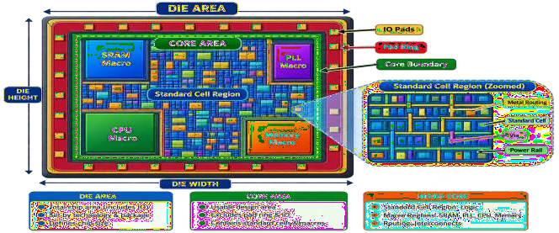

Die Area
The die area represents the complete physical chip boundary.

Core Area
The core area is the region inside the die where standard cells and other core-level physical structures are placed.

CORE UTILIZATION
Core utilization represents how much of the available core area is occupied by standard-cell area. It can be represented approximately as:

𝐶𝑜𝑟𝑒 𝑈𝑡𝑖𝑙𝑖𝑧𝑎𝑡𝑖𝑜𝑛 =
𝑆𝑡𝑎𝑛𝑑𝑎𝑟𝑑 𝐶𝑒𝑙𝑙 𝐴𝑟𝑒𝑎

𝐶𝑜𝑟𝑒 𝐴𝑟𝑒𝑎
× 100

For example, if the target utilization is:
60%
approximately 60% of the available placement area is targeted for standard-cell placement.

Why not use 100% utilization?
Because routing requires free space between cells. Very high utilization can result in:
- Placement congestion
- Routing congestion
- Timing degradation
- Difficult legalization
- Routing failures
Therefore, a reasonable target utilization is normally selected according to the design and technology.

ASPECT RATIO

The aspect ratio determines the shape of the core.

𝐴𝑠𝑝𝑒𝑐𝑡 𝑅𝑎𝑡𝑖𝑜 =

𝐶𝑜𝑟𝑒 𝐻𝑒𝑖𝑔ℎ𝑡

𝐶𝑜𝑟𝑒 𝑊𝑖𝑑𝑡ℎ

For:
Aspect Ratio = 1.0
the core is approximately square.

Example:

Aspect Ratio = 1.0
↓ Square floorplan

Whereas:

and:

Aspect Ratio > 1
↓
Taller core

Aspect Ratio < 1
↓ Wider core

FLOORPLAN INITIALIZATION FLOW
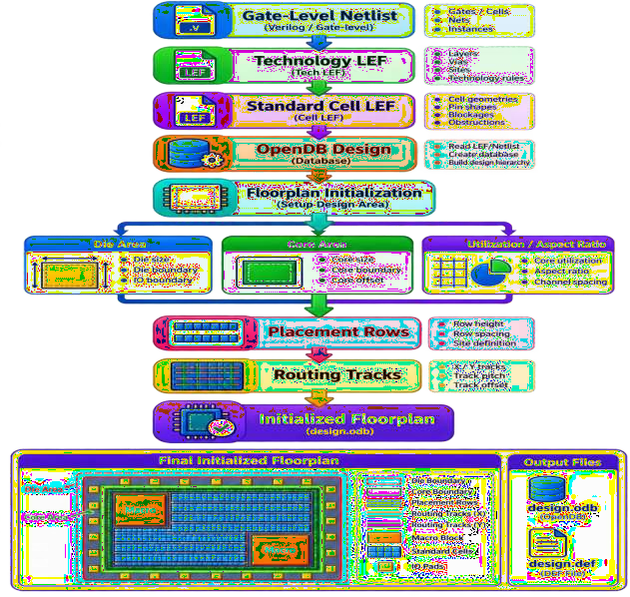

PROCEDURE

Step 1: Create a Working Directory
Open the terminal:
- mkdir -p ~/openroad_exp4 Move into the directory:
- cd ~/openroad_exp4 Check the current directory:
- pwd

STEP 2: Start OpenROAD
Execute:
- openroad
The OpenROAD prompt appears:
- OpenROAD>
Check the version:
- version

STEP 3: READ TECHNOLOGY LEF
Read the technology LEF:
- read_lef <technology.lef> Example:
- read_lef /path/to/tech.lef
The technology LEF provides information about:
- Metal layers
- Via layers
- Manufacturing grid
- Routing rules
- Placement sites

STEP 4: READ STANDARD-CELL LEF
Read the standard-cell LEF:
- read_lef <standard_cell.lef> Example:
- read_lef /path/to/standard_cell.lef The standard-cell LEF provides:

- Cell dimensions
- Cell pins
- Pin locations
- Cell obstructions
- Placement information

STEP 5: READ LIBERTY FILE
Read the standard-cell timing library:
- read_liberty <standard_cell.lib>
Example:
- read_liberty /path/to/standard_cell.lib

STEP 6: READ THE SYNTHESIZED NETLIST
Read the synthesized netlist generated in Experiment-2:
- read_verilog synthesized_netlist.v

STEP 7: LINK THE DESIGN
Specify the top-level module:
- link_design <TOP_MODULE>
For example:
- link_design and_gate
Check the design:
- report_design_area

STEP 8: INITIALIZE THE FLOORPLAN
Use the initialize_floorplan command.

Example:
initialize_floorplan \
-utilization 60 \
-aspect_ratio 1.0 \
-core_space 10 \
-site <SITE>

Here:

Parameter | Meaning
-utilization 60 | Target core utilization = 60%
-aspect_ratio 1.0 | Square core
-core_space 10 | Core-to-die spacing

Parameter | Meaning
-site <SITE> | Standard-cell placement site

Important: The site name is technology-dependent. Use the site name defined in your LEF.

STEP 9: CHECK FLOORPLAN
After initialization, inspect the floorplan. Run:
- report_design_area
You can also check the design database using:
- report_units
If available in your OpenROAD version, use:
- check_placement

STEP 10: GENERATE ROUTING TRACKS

Execute:
- make_tracks
Routing tracks provide legal locations for routing wires on different metal layers. The routing structure can be visualized as:
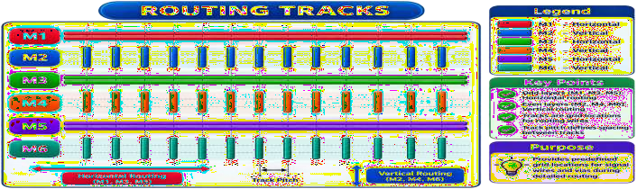

Different layers generally have preferred routing directions.

STEP 11: OPEN THE GUI
You can inspect the floorplan using:
- openroad -gui
Alternatively, if OpenROAD is already running with GUI support, use the GUI from the current session. Inspect:
- Die boundary
- Core boundary
- Placement rows
- Standard-cell region
- Routing tracks
- I/O locations if present
- Macros if present

STEP 12: SAVE THE FLOORPLAN
Write the floorplan to DEF:
- write_def floorplan.def
Save the OpenDB database:
- write_db floorplan.odb
Check the files:
- ls -lh
Expected output includes:
- floorplan.def
- floorplan.odb

COMPLETE OPENROAD COMMAND SEQUENCE
The complete basic sequence is:
- read_lef <technology.lef>
- read_lef <standard_cell.lef>
- read_liberty <standard_cell.lib>

- read_verilog synthesized_netlist.v
- link_design <TOP_MODULE>

- report_design_area

- initialize_floorplan \
- -utilization 60 \
- -aspect_ratio 1.0 \
- -core_space 10 \
- -site <SITE>

- make_tracks
- check_placement

- write_def floorplan.def
- write_db floorplan.odb

FLOORPLAN PARAMETERS

Utilization
Example:
      - -utilization 60 Target utilization:
      - 60%

Aspect Ratio
Example:
      - -aspect_ratio 1.0
This creates a square-like core.

Core Space
Example:
      - -core_space 10
This defines spacing between the core and die boundary when using automatic floorplan sizing.

Explicit Floorplan Coordinates
Instead of utilization-based sizing, explicit die/core coordinates can also be specified. For example:
initialize_floorplan \
-die_area "0 0 1000 1000" \
-core_area "100 100 900 900" \
-site <SITE>
This defines:
Die:
- (0,0) → (1000,1000)

Core:
- (100,100) → (900,900)
The exact values should be selected according to the target design and technology.

FLOORPLAN WITH MACROS

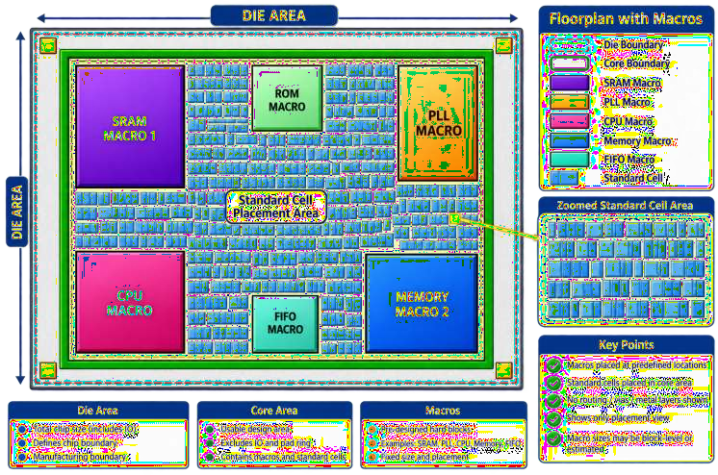

Macros should be placed carefully to avoid:
- Routing congestion
- Narrow channels
- Notches
- Timing problems
- Power-grid problems

OBSERVATION TABLE
Record the following values:

Parameter | Observation
OpenROAD Version
Design Name
Top Module
Technology
Standard Cell Library
Site Name
Target Utilization
Aspect Ratio
Die Width
Die Height
Core Width
Core Height
Die Area
Core Area
Number of Rows
Routing Tracks
Floorplan DEF
Floorplan ODB

  - ANALYSIS

  - EXPECTED OUTPUT

  - RESULT

- CONCLUSION

EXPERIMENT–5
Title
Develop Power Grid Planning Using PDNGEN Contact Hours: 2 Hours

AIM
To develop a Power Distribution Network (PDN) for a digital chip using PDNGEN in OpenROAD, and to analyze the connectivity of VDD and VSS through power rings, straps, rails, and vias.

OBJECTIVES
After completing this experiment, the student will be able to:
- Understand the concept of power planning in physical design.
- Understand the structure of a Power Distribution Network.
- Understand VDD and VSS power connections.
- Create global power and ground connections.
- Define a voltage domain.
- Generate power rings.
- Generate power straps.
- Generate standard-cell power rails.
- Connect different metal layers using vias.
- Verify the generated PDN using OpenROAD.

SOFTWARE / TOOLS REQUIRED

S.No. | Software / Tool | Purpose
1 | Ubuntu/Linux | Operating environment
2 | OpenROAD | Physical design
3 | PDNGEN | Power-grid generation
4 | OpenDB | Design database
5 | LEF | Technology and physical information
6 | Liberty | Timing/library information
7 | DEF | Physical design information
8 | Verilog | Gate-level netlist
9 | GVim | Tcl/script editing

THEORY

Introduction to Power Planning
Power planning is an important physical-design stage in which the power and ground network of the chip is created.
The main purpose of the power distribution network is to deliver a stable supply voltage to all standard cells, macros and other circuit blocks.
A simplified power network is:
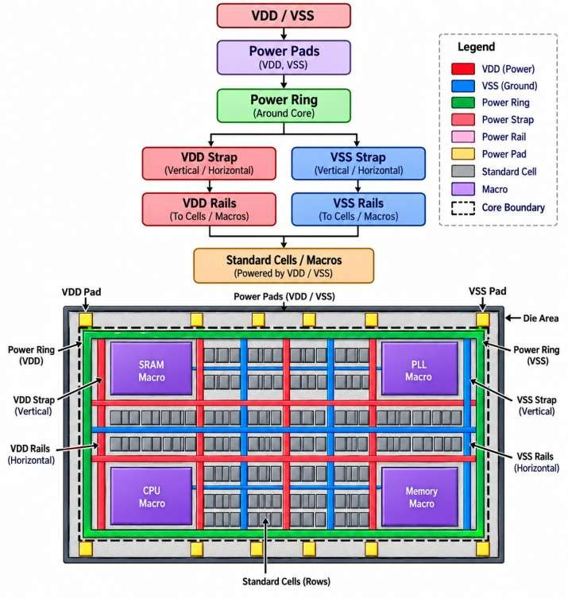

WHAT IS PDN?
PDN stands for Power Distribution Network. It provides electrical connections between:
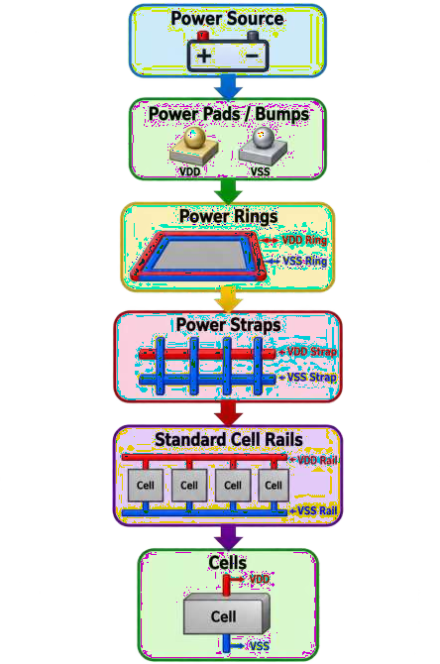

The two primary supply nets are:
- VDD – Power supply
- VSS – Ground

IMPORTANCE OF POWER PLANNING
A properly designed PDN should:
- Deliver sufficient voltage to all cells.
- Minimize IR drop.
- Reduce electromigration risk.
- Provide low-resistance power paths.
- Maintain VDD/VSS connectivity.
- Support high switching activity.
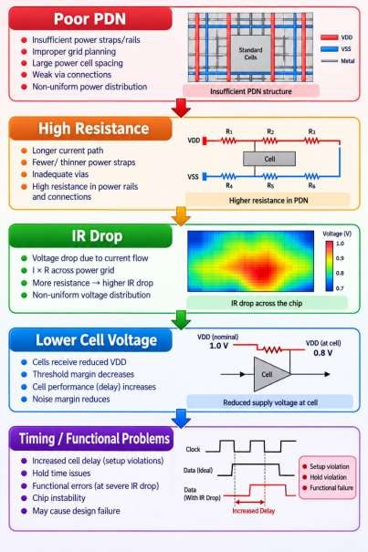
- Provide adequate current capacity. Poor power planning can cause:

POWER DISTRIBUTION NETWORK STRUCTURE
A typical PDN consists of:

Power Pads / Bumps
Provide external VDD/VSS connections.

Power Rings
Large metal structures around the core.

Power Straps
Horizontal and vertical metal lines that distribute power across the core.

Follow-Pin Rails
Power rails that follow standard-cell rows.

Vias
Connect power structures between different metal layers.

TYPICAL PDN STRUCTURE
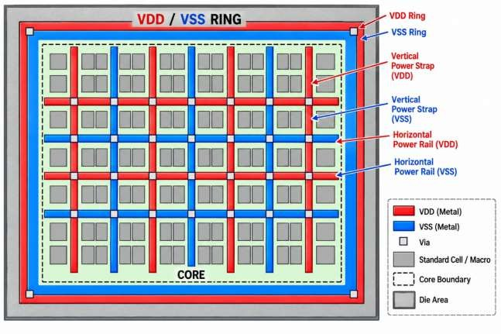

The vertical and horizontal structures form a mesh that distributes VDD and VSS.

PDNGEN
PDNGEN is the OpenROAD power-grid generation module.
It generates the physical power network according to a specified PDN configuration. PDNGEN can create:
- Rings
- Straps
- Follow-pin rails
- Layer connections
- Power-grid structures

INPUTS REQUIRED
The experiment requires:
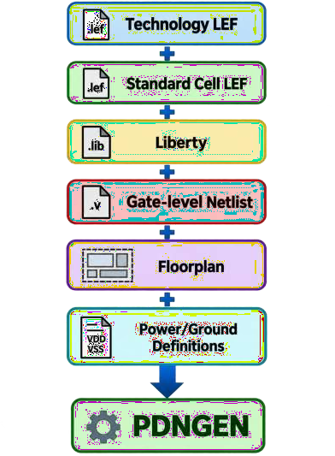

The floorplan generated in Experiment-4 is used as the starting point.

PROCEDURE

Step 1: Create Working Directory
Open the terminal:
- Cd: mkdir -p ~/openroad_exp5 Move into it:
- Cd: cd ~/openroad_exp5

STEP 2: START OPENROAD
Run:
- openroad Check the version:
- version

STEP 3: LOAD THE FLOORPLAN DATABASE
If the database generated in Experiment-4 is available:
- read_db floorplan.odb
Alternatively, load the required files:
- read_lef <technology.lef>
- read_lef <standard_cell.lef>
- read_liberty <standard_cell.lib>
- read_verilog <synthesized_netlist.v>
- link_design <TOP_MODULE>
Then initialize the required floorplan if it has not already been saved.

STEP 4: CHECK THE DESIGN
Run:
- report_design_area Check placement:
- check_placement
Make sure the floorplan is valid before creating the PDN.

STEP 5: CREATE GLOBAL POWER CONNECTION
The standard cells must be connected to the global VDD net.

Example:tcl

add_global_connection \
-net VDD \
-pin_pattern {^VDD$} \

-power
This tells OpenROAD that pins matching VDD should connect to the global power net.

STEP 6: CREATE GLOBAL GROUND CONNECTION

Create the VSS connection:
Tcl:
add_global_connection \
-net VSS \
-pin_pattern {^VSS$} \
-ground
Now the design has:
- VDD → Power
- VSS → Ground
Note: Standard-cell power-pin names are technology/library dependent. In your library they may be VDD, VSS, VPWR, VGND, or other names. Use the actual names from your LEF/Liberty.

STEP 7: DEFINE VOLTAGE DOMAIN
Define the core voltage domain:
Tcl:
set_voltage_domain \
-power VDD \
-ground VSS
The voltage domain identifies the power and ground nets used by the core.

STEP 8: DEFINE PDN GRID

Create a PDN grid:
- define_pdn_grid -name Core Here:
Core
↓ PDN Grid
The grid will contain the power structures used to distribute VDD and VSS.

STEP 9: ADD POWER RING
A power ring is created around the core.

Example:
add_pdn_ring \
-grid Core \
-layers {M8 M9} \
-widths {5.0 5.0} \
-spacings {2.0 2.0} \
-core_offsets {4.5 4.5}
The exact metal layers, widths, spacings and offsets are technology dependent. Conceptually:
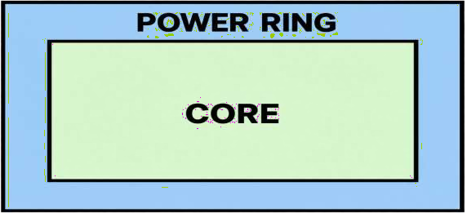

STEP 10: ADD FOLLOW-PIN RAILS
Standard cells require power and ground rails.

Example:
add_pdn_stripe \
-grid Core \
-followpins \
-layer M1
This creates follow-pin power rails along standard-cell rows.

Conceptually:
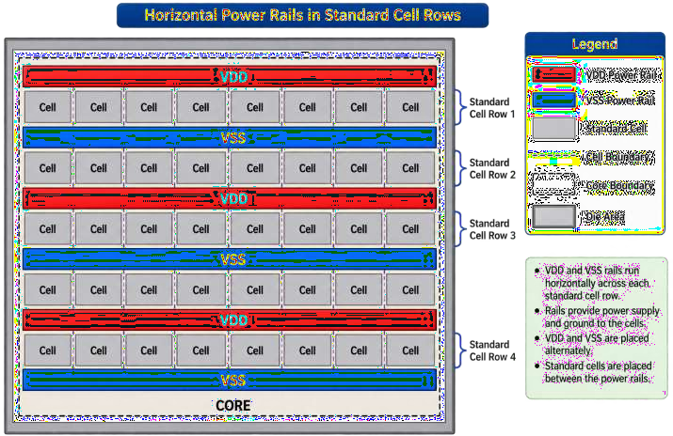

STEP 11: ADD POWER STRAPS

Add vertical/horizontal straps on higher metal layers. Example:
Tcl:
add_pdn_stripe \
-grid Core \
-layer M4 \
-width 0.48 \
-pitch 56.0 \
-offset 2.0

Another layer can be added:

Tcl: add_pdn_stripe \
-grid Core \
-layer M5 \
-width 0.48 \

-pitch 56.0 \
-offset 2.0
The straps form the power mesh.

STEP 12: CONNECT DIFFERENT METAL LAYERS
Power structures on different layers must be electrically connected.

Example: tcl:
add_pdn_connect \
-grid Core \
-layers {M1 M4}

Another connection:
tcl:
add_pdn_connect \
-grid Core \
-layers {M4 M5}

Vias are automatically generated according to the PDN configuration and technology rules.

STEP 13: GENERATE THE PDN
Execute:
- pdngen
PDNGEN now generates the specified:
- Power Rings
- Power Straps
- Follow-Pin Rails
- Vias
- VDD Connections
- VSS Connections

STEP 14: CHECK POWER GRID
Inspect the generated PDN in the OpenROAD GUI. Start GUI:
- openroad -gui
The PDN should look conceptually like:

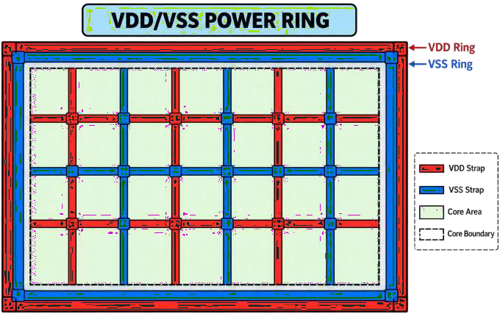

STEP 15: CHECK FOR FLOATING PDN STRIPES
Run the PDN analysis/checking commands supported by your OpenROAD version. A typical verification is:
- check_power_grid
If the command is not available in your installed version, use the PDN/IR analysis commands provided by that version and inspect the generated PDN visually and through the logs.
The objective is to identify:
- Floating stripes
- Missing connections
- Disconnected rails
- Incorrect VDD/VSS connections

STEP 16: SAVE THE PDN DATABASE
Save the database:
- write_db pdn.odb Write the DEF:
- write_def pdn.def

Check the generated files:
- ls -lh
- Expected:
- pdn.odb
- pdn.def

COMPLETE PDNGEN COMMAND SEQUENCE
A representative sequence is: tcl:
read_db floorplan.odb

add_global_connection \
-net VDD \
-pin_pattern {^VDD$} \
-power

add_global_connection \
-net VSS \
-pin_pattern {^VSS$} \
-ground

set_voltage_domain \
-power VDD \
-ground VSS
define_pdn_grid -name Core add_pdn_ring \
-grid Core \
-layers {M8 M9} \
-widths {5.0 5.0} \
-spacings {2.0 2.0} \
-core_offsets {4.5 4.5}

add_pdn_stripe \
-grid Core \
-followpins \
-layer M1

add_pdn_stripe \
-grid Core \
-layer M4 \
-width 0.48 \

-pitch 56.0 \
-offset 2.0

add_pdn_stripe \
-grid Core \
-layer M5 \
-width 0.48 \
-pitch 56.0 \
-offset 2.0

add_pdn_connect \
-grid Core \
-layers {M1 M4}

add_pdn_connect \
-grid Core \
-layers {M4 M5} pdngen
- write_db pdn.odb
- write_def pdn.def

Important: The metal-layer names and numerical values above are examples. Use the values defined for your selected technology/PDK.

PDN GENERATION FLOW
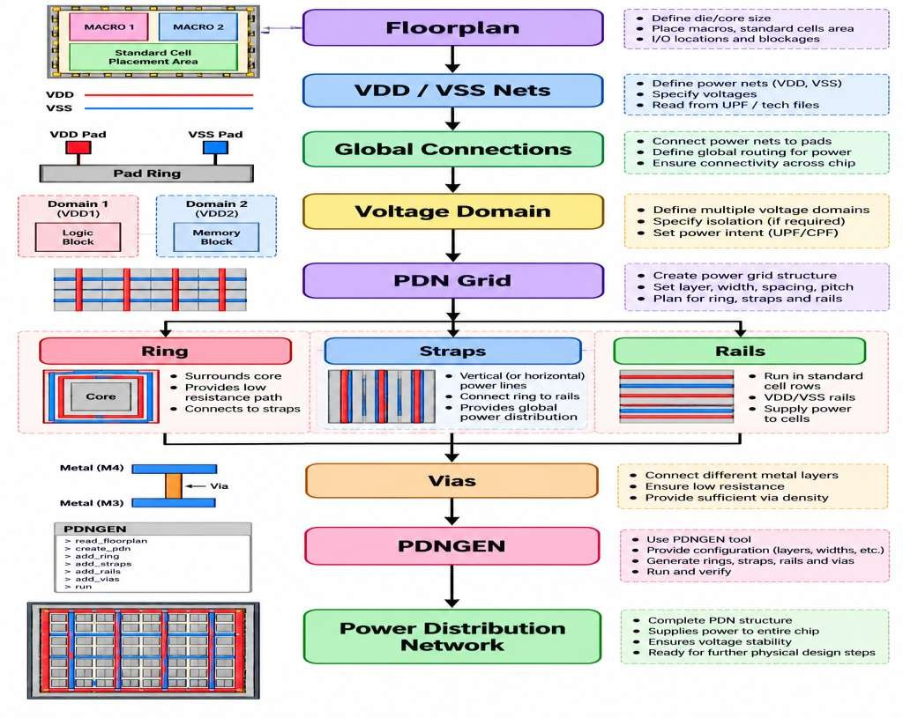

OBSERVATION TABLE

Parameter | Observation
OpenROAD Version
Design Name
Technology
Power Net
Ground Net
Voltage Domain
PDN Grid Name
Ring Layers
Ring Width
Ring Spacing
Strap Layers
Strap Width
Strap Pitch
Follow-Pin Layer
Number of Power Straps
Number of Ground Straps
PDN DEF
PDN ODB

  - ANALYSIS

33. EXPECTED OUTPUT

34. RESULT

37. CONCLUSION

EXPERIMENT–6
Title
Learn the Pin Placement Using ioPlacer Contact Hours: 2 Hours

AIM
To perform I/O pin placement using the ioPlacer (PPL) module in OpenROAD and understand how input and output pins are positioned on the boundary of the chip according to specified placement constraints.

OBJECTIVES

After completing this experiment, the student will be able to:
- Understand the concept of I/O pin placement.
- Understand the role of ioPlacer/PPL in physical design.
- Identify input and output ports in a design.
- Define pin-placement constraints.
- Specify horizontal and vertical routing layers for pins.
- Place I/O pins along the chip boundary.
- Analyze pin spacing and routing accessibility.
- Save the pin-placement information for further physical-design stages.

SOFTWARE / TOOLS REQUIRED

S.No. | Software / Tool | Purpose
1 | Ubuntu/Linux | Operating environment
2 | OpenROAD | Physical design
3 | ioPlacer / PPL | I/O pin placement
4 | OpenDB | Design database
5 | LEF | Technology/physical information
6 | Liberty | Timing information
7 | DEF | Physical design information
8 | Verilog | Gate-level netlist
9 | GVim | Tcl/script editing

THEORY

Introduction to I/O Pin Placement
I/O pin placement is the process of assigning physical locations to the input and output pins of a chip.
I/O pins are generally placed around the boundary of the core or die so that signals can enter and leave the chip.
A simplified representation is:
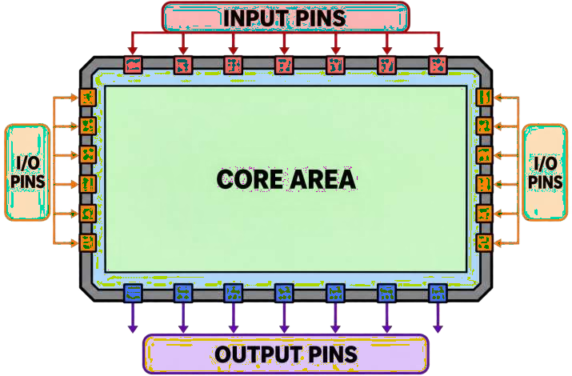

Good I/O pin placement is important because it affects:
    - Routing congestion
    - Wirelength
    - Timing
    - Signal integrity
    - Routing accessibility
    - Chip-level connectivity

WHAT IS ioPlacer?
ioPlacer, commonly associated with OpenROAD's PPL (Pin Placer) module, is used to automatically place I/O pins along the boundary of the design.
It can consider:
- Pin direction
- Pin location
- Pin layer
- Pin spacing
- Pin order
- Region constraints
- Routing tracks
The pin placer can optimize pin locations to reduce estimated wirelength while respecting the specified constraints.

I/O PIN TYPES
The main types of design I/O pins are:

Input Pins
Input pins receive signals from outside the design. Example:
    - A ─────►
    - B ─────►
    - CLK ───►
    - RST ───►

Output Pins
Output pins send signals outside the design.
    - ─────► Y
    - ─────► OUT

Bidirectional Pins
Bidirectional pins can act as both inputs and outputs.
    - ◄────► DATA

PIN PLACEMENT CONCEPT
A typical pin placement can be represented as:
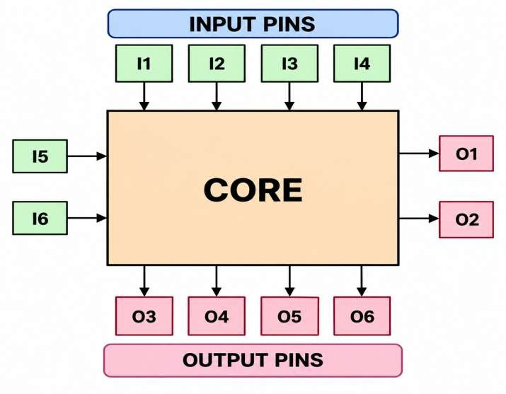
The actual pin locations depend on the constraints and design connectivity.

INPUTS REQUIRED
The experiment requires:
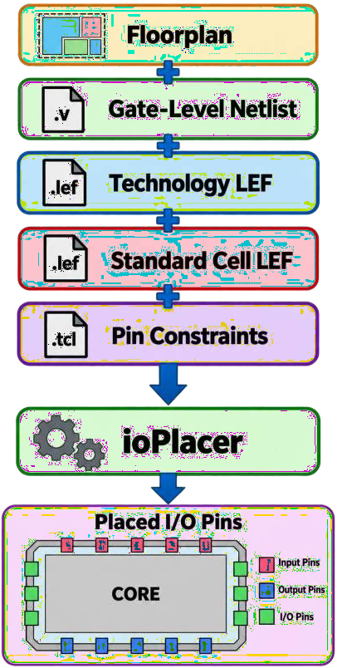

PROCEDURE

Step 1: Create Working Directory
Open the Linux terminal:
- mkdir -p ~/openroad_exp6 Move into the directory:
- cd ~/openroad_exp6 Check the current directory:
- pwd

STEP 2: START OPENROAD
Run:
- openroad Check the version:
- version
Check the pin-placement commands:
- help place_pins You can also check:
- help set_io_pin_constraint

STEP 3: LOAD THE FLOORPLAN DATABASE
Load the database generated from the previous experiment:
- read_db pdn.odb
If the PDN database is not available, load the required design files:
- read_lef <technology.lef>
- read_lef <standard_cell.lef>
- read_liberty <standard_cell.lib>
- read_verilog <synthesized_netlist.v>
- link_design <TOP_MODULE>
Then initialize/read the floorplan as required.

STEP 4: CHECK THE DESIGN
Run:
- report_design_area Check the design placement:
- check_placement

Make sure the floorplan is valid before placing I/O pins.

STEP 5: IDENTIFY DESIGN PORTS
The design may contain ports such as:
Inputs:
- clk
- rst
- a
- b

Outputs:
  - y
The actual ports depend on the selected RTL/netlist.
You can inspect the design through the OpenROAD GUI or use the available database/reporting commands.

STEP 6: DEFINE I/O PIN CONSTRAINTS
I/O pin constraints determine where pins should be placed. For example,
input pins can be constrained to the left side:

tcl:
set_io_pin_constraint \
-direction input \
-region left:*

Output pins can be constrained to the right side:

Tcl:
set_io_pin_constraint \
-direction output \
-region right:*
This gives a conceptual arrangement:

INPUTS OUTPUTS

I1 ──► ◄── O1 I2 ──► CORE ◄── O2 I3 ──► ◄── O3
I4 ──► ◄── O4

STEP 7: CONSTRAIN SPECIFIC PINS
Individual pins can also be constrained. For example:Tcl:
set_io_pin_constraint \
-pin_names {clk rst} \
-region top:*
This places the specified pins in the top region according to the pin-placement constraints. Another example:Tcl:
set_io_pin_constraint \
-pin_names {y} \
-region bottom:*
This constrains output y to the bottom region.
Note: Exact constraint syntax and supported options depend on the OpenROAD version being used. Use help set_io_pin_constraint to verify the syntax in your installation.

STEP 8: SPECIFY PIN LAYERS
The pin placer can be instructed to use particular horizontal and vertical metal layers.

Example:
place_pins \
-hor_layers M3 \
-ver_layers M2 Conceptually:
- Horizontal pin access → M3
- Vertical pin access → M2
The actual metal layers must be selected according to the technology/PDK.

STEP 9: PERFORM PIN PLACEMENT
Run: Tcl place_pins \
-hor_layers M3 \
-ver_layers M2
The pin placer now determines legal locations for the design I/O pins.

The placement considers the defined constraints and available routing tracks.

STEP 10: INSPECT PIN PLACEMENT
Open the OpenROAD GUI:
- openroad -gui Inspect:
  - Input pins
  - Output pins
  - Pin layers
  - Pin spacing
  - Pin order
  - Core boundary
  - Routing tracks Better distributed placement:
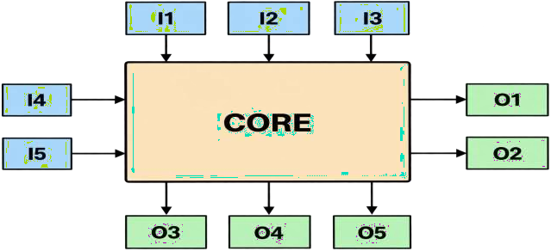

STEP 11: SAVE PIN PLACEMENT
Pin placement can be saved for reuse. Example:
- write_pin_placement pin_placement.tcl Check the generated file:
- ls -lh

Expected:
- pin_placement.tcl

STEP 12: WRITE THE UPDATED DESIGN
Save the updated physical design:
- write_def io_placed.def Save the OpenDB database:
- write_db io_placed.odb Check:
- ls -lh Expected files:
- io_placed.def
- io_placed.odb
- pin_placement.tcl

COMPLETE COMMAND SEQUENCE
A representative command sequence is: read_db pdn.odb
report_design_area check_placement
set_io_pin_constraint \
-direction input \
-region left:*

set_io_pin_constraint \
-direction output \
-region right:*

place_pins \
-hor_layers M3 \
-ver_layers M2

write_pin_placement pin_placement.tcl write_def io_placed.def
write_db io_placed.od

I/O PIN PLACEMENT FLOW
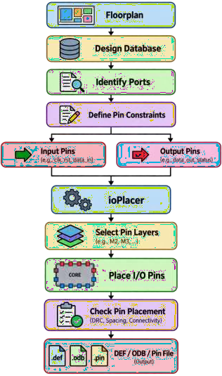

OBSERVATION TABLE

Parameter | Observation
OpenROAD Version
Design Name
Top Module
Number of Input Pins
Number of Output Pins

Parameter | Observation
Number of Bidirectional Pins
Input Pin Region
Output Pin Region
Horizontal Pin Layer
Vertical Pin Layer
Pin Spacing
Pin Placement Status
Pin Placement File
DEF File
ODB File

- ANALYSIS

- EXPECTED OUTPUT

28. RESULT

31. CONCLUSION

EXPERIMENT–7

Title
Place an I/O Ring Around the Boundary of a Chip and Connect with Either Wirebond Pads or a Bump Array
Contact Hours: 2 Hours

AIM
To understand and perform I/O ring placement around the chip boundary and study the connection of I/O terminals using wirebond pads or a bump array in the OpenROAD physical-design flow.

OBJECTIVES
After completing this experiment, the student will be able to:
- Understand the concept of an I/O ring.
- Understand the role of I/O pads in chip-level physical design.
- Understand wirebond and flip-chip packaging.
- Place I/O pads around the chip boundary.
- Understand the purpose of power and ground pads.
- Understand bump-array placement.
- Connect I/O terminals to the corresponding pads or bumps.
- Inspect the completed I/O structure using the OpenROAD environment.
- Save the final I/O-ring design in DEF/OpenDB format.

SOFTWARE / TOOLS REQUIRED

S.No. | Software / Tool | Purpose
1 | Ubuntu/Linux | Operating environment
2 | OpenROAD | Physical design
3 | OpenDB | Design database
4 | ICeWall / Chip-level I/O tools | I/O pad-ring implementation
5 | LEF | Physical library information
6 | Liberty | Timing/library information
7 | DEF | Physical design information
8 | Verilog | Gate-level netlist
9 | GVim | Tcl/configuration editing

THEORY

Introduction to I/O Ring
An I/O ring, also called a pad ring, is a collection of I/O cells or pads placed around the outer boundary of a chip.
It provides the interface between:

External Package
↓

I/O Pads / Bumps
↓

Core Interconnect
↓ Internal Logic

A simplified chip-level structure is:
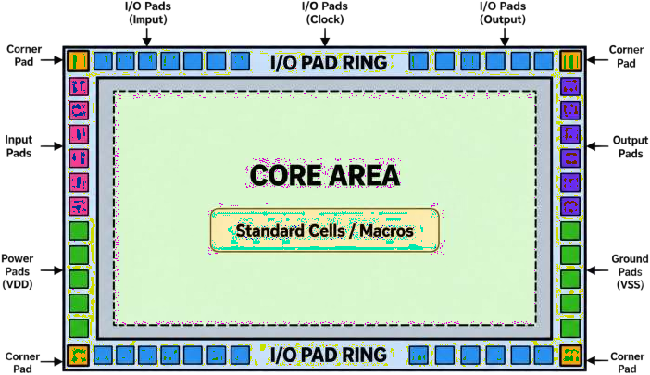

PURPOSE OF AN I/O RING
The I/O ring provides:
- External signal connections
- Power connections
- Ground connections
- ESD protection
- Physical separation between core and package
- Connection to package pins or bumps Typical I/O cells include:
- Input Pad
- Output Pad
- Bidirectional Pad
- Power Pad
- Ground Pad
- Corner Cell
- ESD Cell

WIREBOND PACKAGING
In wirebond packaging, the chip pads are connected to package leads using thin bonding wires. Conceptually:
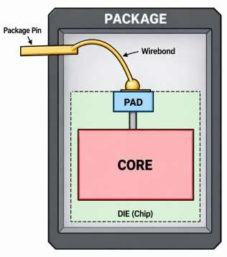

BUMP ARRAY
A bump array is commonly used in flip-chip packaging.
Instead of connecting only around the perimeter, solder bumps can be distributed over a large portion of the chip/package interface.
Conceptually:

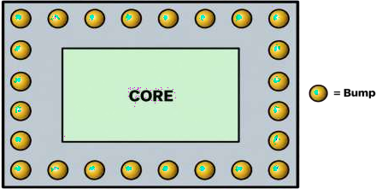

A bump array can provide many signal, power and ground connections.

WIREBOND VS BUMP ARRAY

Parameter | Wirebond | Bump Array
Connection | Bonding wire | Solder bump
Location | Usually chip perimeter | Can cover larger area
Connection density | Lower | Higher
Package type | Wirebond package | Flip-chip/package
Signal path | Longer | Generally shorter
Power distribution | More perimeter dependent | Can be distributed across chip
Typical use | Conventional packaging | High-performance/high-I/O designs

I/O RING STRUCTURE
A typical I/O ring contains:
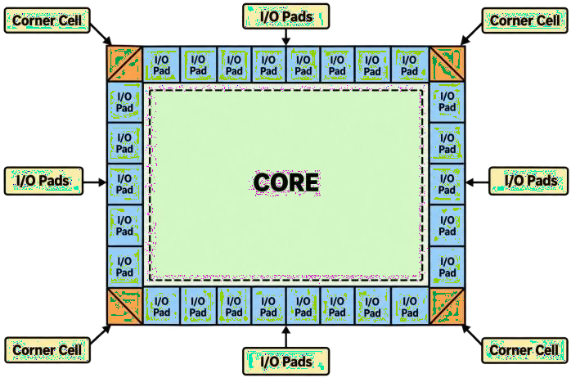

Power and ground pads are distributed around the ring to provide adequate supply connectivity.

INPUTS REQUIRED
The experiment requires:
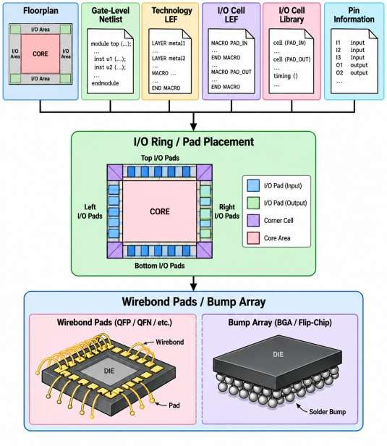

The design from Experiment-6 can be used as the starting point.

PROCEDURE

Step 1: Create Working Directory
Open the Linux terminal:
- mkdir -p ~/openroad_exp7 Move into the directory:
- cd ~/openroad_exp7

Check the directory:
- pwd

STEP 2: START OPENROAD
Run:
- openroad Check the version:
version
Check available I/O-related commands:
help

STEP 3: LOAD THE PREVIOUS DESIGN
Load the database generated after I/O pin placement:
- read_db io_placed.odb
If the database is unavailable, load the required design files:
- read_lef <technology.lef>
- read_lef <standard_cell.lef>
- read_lef <io_cell.lef>

- read_liberty <standard_cell.lib>
- read_verilog <synthesized_netlist.v>

- link_design <TOP_MODULE>

STEP 4: CHECK THE FLOORPLAN
Run:
- report_design_area Check placement:
- check_placement
The die and core boundaries should already be available from the previous floorplanning stage.

STEP 5: LOAD I/O PAD INFORMATION
I/O pad cells must be available in the selected technology library. Typical I/O cells may include:
- PAD_IN
- PAD_OUT
- PAD_BIDIR
- PAD_VDD
- PAD_VSS
- PAD_CORNER
The actual cell names depend on the selected PDK.
Check the available library cells using the library/technology information supplied with the PDK.

STEP 6: UNDERSTAND PAD ASSIGNMENT
Create a pad assignment conceptually as:
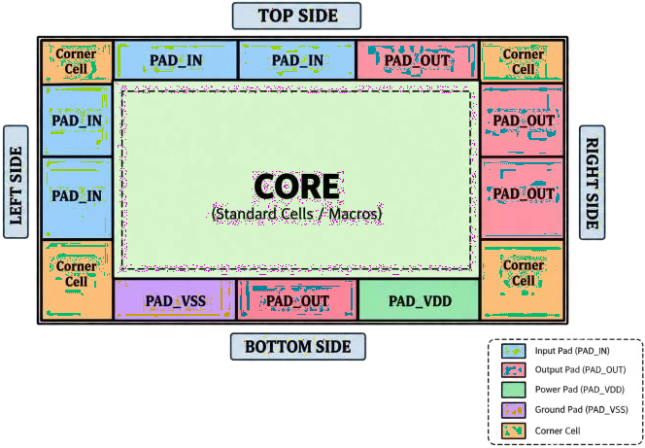

The actual assignment is technology and package dependent.

STEP 7: PLACE I/O TERMINALS
OpenROAD provides chip-level I/O functionality through its pad/chip-level flow. A representative operation for placing terminals is:
- place_io_terminals <IO_INSTANCES> For example:
- place_io_terminals u_in*
or:
- place_io_terminals u_out*
The exact instance patterns depend on the design.

STEP 8: PLACE POWER AND GROUND PADS
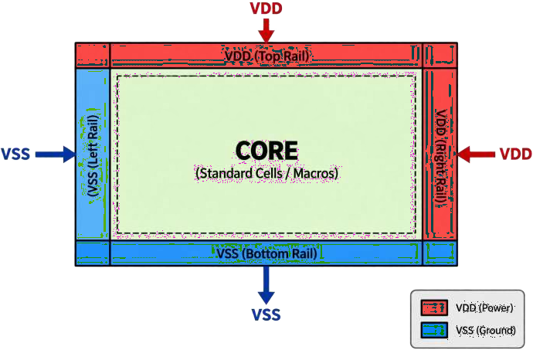
Power and ground pads must be distributed appropriately. Conceptually:

Power and ground pads should be connected to the corresponding power network.

STEP 9: CORNER CELLS
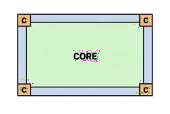
Corner cells are used at the four corners of the I/O ring.

Where:
C = Corner Cell
Corner cells help complete the physical continuity of the pad ring and may also provide required ESD/power-ring structures depending on the technology.

STEP 10: CREATE A BUMP ARRAY
For a flip-chip style implementation, a bump array can be generated using the chip-level I/O flow. A representative command is:Tcl:
make_io_bump_array \
-bump <BUMP_MASTER> \
-origin {200 200} \
-rows 14 \
-columns 14 \
-pitch {200 200} Here:
Parameter | Meaning
-bump | Bump master cell
-origin | Starting coordinate
-rows | Number of bump rows
-columns | Number of bump columns
-pitch | Distance between bumps

Important: The bump master, coordinates, rows, columns and pitch are only examples. They must be replaced with values supported by your PDK/package technology.

BUMP ARRAY STRUCTURE

Example:
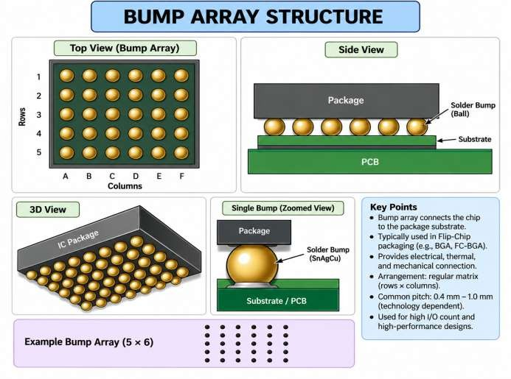
The bumps can be assigned for:
- Signal
- VDD
- VSS
- Clock
- Reset
- Other power domains

STEP 11: CONNECT I/O PADS/BUMPS
The pads or bumps must be electrically connected to the corresponding design nets. Conceptually:
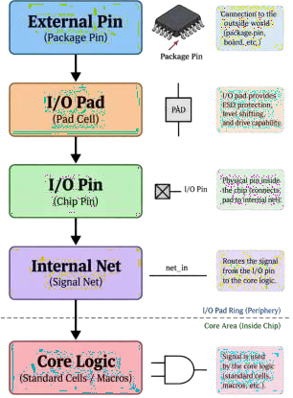

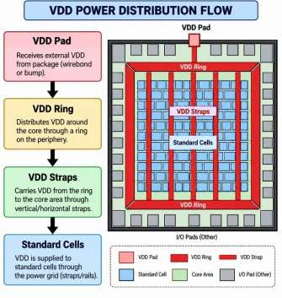
For power:

STEP 12: INSPECT USING OPENROAD GUI
Launch the GUI:
- openroad -gui Inspect:
  - I/O pads
  - Corner cells
  - Core boundary
  - Die boundary
  - Power pads
  - Ground pads
  - Signal pads
  - Bump array
  - Connections

STEP 13: CHECK I/O PLACEMENT
Check that:
- Pads do not overlap.
- Corner cells are correctly positioned.
- Signal pads are connected to the correct ports.
- Power pads connect to VDD.
- Ground pads connect to VSS.
- The I/O ring surrounds the required core boundary.
- Bumps are placed at legal locations.
- Sufficient spacing is maintained between pads/bumps.

STEP 14: SAVE THE I/O-RING DESIGN
Save the updated database:
- write_db io_ring.odb Write the DEF:
- write_def io_ring.def Check the files:
- ls -lh Expected files:
- io_ring.odb
- io_ring.def

COMPLETE REPRESENTATIVE COMMAND SEQUENCE
read_db io_placed.odb report_design_area check_placement place_io_terminals u_*
make_io_bump_array \
-bump <BUMP_MASTER> \
-origin {200 200} \
-rows 14 \
-columns 14 \
-pitch {200 200}
write_db io_ring.odb write_def io_ring.def

The exact I/O-ring and pad/bump commands depend on the OpenROAD version and the PDK's I/O-cell definitions. Always verify the available syntax using help in your installed OpenROAD build.

I/O RING FLOW
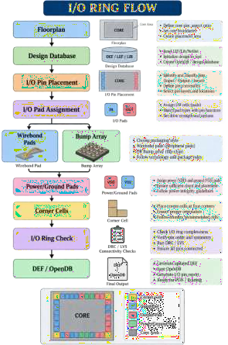

OBSERVATION TABLE

Parameter | Observation
OpenROAD Version
Design Name
Top Module
Number of Input Pads
Number of Output Pads
Number of Bidirectional Pads
Number of Power Pads
Number of Ground Pads
Number of Corner Cells
I/O Ring Type
Bump Master
Number of Bump Rows
Number of Bump Columns
Bump Pitch
Pad Placement Status
Bump Placement Status
Final DEF
Final ODB

- ANALYSIS

- EXPECTED OUTPUT

- RESULT

34. CONCLUSION

EXPERIMENT–8
Explore OpenSTA as a Gate-Level Static Timing Verifier and as a Stand-Alone Executable to Verify the Timing of a Design Using Standard File Formats
Contact Hours: 2 Hours

AIM
To explore OpenSTA (Open Static Timing Analyzer) as a gate-level static timing analysis tool and as a stand-alone executable, and to verify the timing characteristics of a synthesized design using standard timing-related file formats such as Verilog, Liberty, SDC, SPEF, and SDF.

OBJECTIVES
- After completing this experiment, the student should be able to:
- Understand the concept of Static Timing Analysis (STA).
- Understand the role of OpenSTA in the ASIC physical design flow.
- Run OpenSTA as a stand-alone executable.
- Load a gate-level Verilog netlist into OpenSTA.
- Read standard-cell timing information from a Liberty (.lib) file.
- Read timing constraints from an SDC (.sdc) file.
- Create and analyze timing paths.
- Understand:
  - Setup timing
  - Hold timing
  - Slack
  - Arrival time
  - Required time
  - Clock period
  - Clock skew
- Generate timing reports using OpenSTA.
- Understand how parasitic information such as SPEF affects timing analysis.

SOFTWARE / TOOLS REQUIRED

S.No. | Software / File | Purpose
1  2  3  4  5  6 | Linux / Ubuntu | Operating environment
1  2  3  4  5  6 | OpenSTA | Static timing analysis
1  2  3  4  5  6 | OpenROAD | Physical design flow integration
1  2  3  4  5  6 | Yosys | RTL synthesis
1  2  3  4  5  6 | GVim / Vim | Editing Verilog and SDC files
1  2  3  4  5  6 | Gate-level Verilog | Design netlist

S.No.  7  8  9  10 | Software / File | Purpose
S.No.  7  8  9  10 | Liberty .lib | Cell delay and timing information
S.No.  7  8  9  10 | SDC .sdc | Timing constraints
S.No.  7  8  9  10 | SPEF .spef | Parasitic information
S.No.  7  8  9  10 | SDF .sdf | Delay annotation information

THEORY

What is Static Timing Analysis?
Static Timing Analysis (STA) is a method used to verify whether a digital design can operate correctly at the required clock frequency without applying simulation vectors.
Instead of simulating every possible input combination, STA mathematically analyzes timing paths between sequential and combinational elements.
A simplified timing path is:
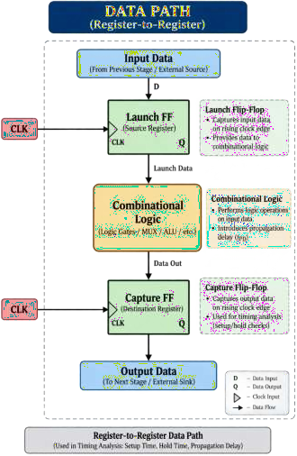

WHAT IS OpenSTA?
OpenSTA is an open-source static timing analysis engine used to verify the timing of gate-level digital designs. It can analyze timing using standard industry file formats including:
- Verilog – gate-level connectivity
- Liberty (.lib) – standard-cell timing and power models
- SDC (.sdc) – timing constraints
- SPEF (.spef) – extracted parasitic resistance and capacitance
- SDF (.sdf) – delay annotation
- VCD / SAIF – switching activity information for power-related analysis OpenSTA can be used independently or as part of the OpenROAD physical-design flow.

ROLE OF OPENSTA IN ASIC FLOW
A simplified ASIC flow is:
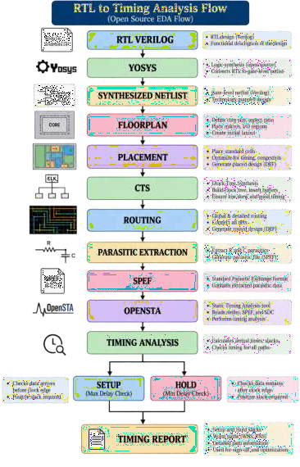

OpenSTA can therefore be used at different stages to determine whether timing requirements are satisfied.

IMPORTANT STA CONCEPTS

Clock
A clock controls the operation of sequential circuits. For example:
create_clock -name clk -period 10 [get_ports clk] Here:
Clock period = 10 ns
Frequency = 1 / 10 ns
= 100 MHz

Clock Frequency
The relationship between clock period and frequency is:
1
𝐹 =
𝑇

For a 10 ns clock:

SETUP TIMING

𝐹 =

1

10𝑛𝑠

= 100𝑀𝐻𝑧

Setup timing verifies that data reaches the capture flip-flop sufficiently before the active clock edge. Simplified representation:
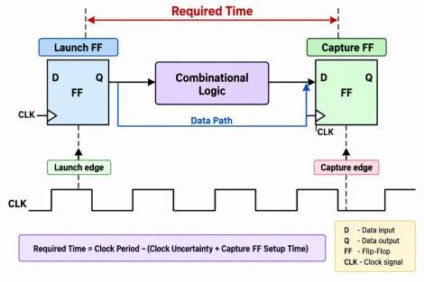
A simplified setup condition is:
𝑇𝑐𝑙𝑘 ≥ 𝑇𝑐𝑞 + 𝑇𝑙𝑜𝑔𝑖𝑐 + 𝑇𝑠𝑒𝑡𝑢𝑝

If the data arrives too late, a setup violation occurs.

HOLD TIMING
Hold timing verifies that data does not change too quickly after the capture clock edge.
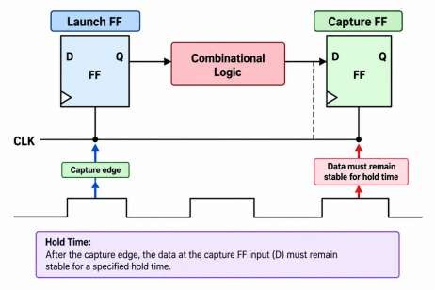
A hold violation occurs when the new data reaches the capture element too early.

SLACK
Slack indicates whether a timing path satisfies its timing requirement.

Setup Slack
𝑆𝑙𝑎𝑐𝑘 = 𝑅𝑒𝑞𝑢𝑖𝑟𝑒𝑑 𝑇𝑖𝑚𝑒 − 𝐴𝑟𝑟𝑖𝑣𝑎𝑙 𝑇𝑖𝑚𝑒

Example:
Required time = 10 ns Arrival time = 8 ns

Slack = 10 - 8
= +2 ns
Therefore, the path passes setup timing.

Negative Slack
Required time = 10 ns Arrival time = 11 ns

Slack = 10 - 11
= -1 ns
The path has a 1 ns setup violation.

WNS AND TNS

WNS – Worst Negative Slack
WNS represents the worst timing violation in the design. Example:
Path 1 = +0.50 ns
Path 2 = -0.20 ns

Path 3 = -0.80 ns WNS = -0.80 ns

TNS – Total Negative Slack
TNS represents the sum of negative slack values for violating paths. For example:
Slack 1 = -0.2 ns
Slack 2 = -0.5 ns
Slack 3 = -0.3 ns

TNS = -1.0 ns
For a timing-clean design:
WNS ≥ 0
TNS = 0

INPUT FILES FOR OPENSTA

Gate-Level Verilog
The Verilog netlist describes the connectivity of standard cells. Example:
module top ( input clk, input a, input b, output y
);
wire n1;

AND2_X1 U1 (
.A(a),
.B(b),
.Y(n1)
);
DFF_X1 U2 (
.D(n1),
.CK(clk),
.Q(y)
);

endmodule

Liberty File
The Liberty file contains information such as:
    - Cell area
    - Input capacitance
    - Output capacitance
    - Cell delay
    - Transition
    - Timing arcs
    - Setup time
    - Hold time
    - Leakage power
    - Dynamic power Example:
cell (AND2_X1) { area : 1.0;

pin(A) {
direction : input;
}

pin(Y) {
direction : output;
}
}
Actual Liberty files are much more detailed and are supplied by the technology library/PDK.

SDC FILE
SDC = Synopsys Design Constraints
SDC describes the timing requirements of the design. Typical constraints include:
- create_clock
- set_input_delay
- set_output_delay
- set_clock_uncertainty
- set_clock_latency
- set_false_path
- set_multicycle_path
- set_max_delay
- set_min_delay

Example:
- create_clock -name clk -period 10 [get_ports clk] Input delay:
- set_input_delay 2.0 -clock clk [get_ports a] Output delay:
- set_output_delay 2.0 -clock clk [get_ports y]

SPEF FILE
SPEF = Standard Parasitic Exchange Format
SPEF contains extracted parasitic information such as:
- Resistance
- Capacitance
- Coupling capacitance

After routing:

Routing
│
▼
Parasitic Extraction
│
▼
SPEF
│
▼
STA
│
▼
Post-route timing
Post-route timing is generally more realistic because routing parasitics affect the delay.

PROCEDURE

Step 1 – Check OpenSTA Installation
Open a terminal:
- opensta -version
If the executable is available, the installed version is displayed. Depending on the installation, the executable may also be invoked as:
- sta Check:
- which opensta
- which sta

Step 2 – Create an Experiment Directory
- mkdir -p ~/opensta_exp8
- cd ~/opensta_exp8

Step 3 – Prepare the Design Files
The basic STA setup requires:
opensta_exp8/
│
├── synthesized_netlist.v
├── constraints.sdc
└── standard_cell.lib

For post-route analysis:
opensta_exp8/
│
├── synthesized_netlist.v
├── constraints.sdc
├── standard_cell.lib
└── design.spef

Step 4 – Create an SDC Constraint File
Open the file:
gvim constraints.sdc Example:
create_clock -name clk -period 10 [get_ports clk] set_clock_uncertainty 0.2 [get_clocks clk]
set_input_delay 1.0 \
-clock clk \
[get_ports a]
set_input_delay 1.0 \
-clock clk \
[get_ports b]
set_output_delay 1.0 \
-clock clk \
[get_ports y] Save the file.

Step 6 – Read the Liberty File
Inside OpenSTA:
  - read_liberty <standard_cell.lib> Example:
  - read_liberty NangateOpenCellLibrary_typical.lib
The Liberty file provides the timing models for the standard cells.

Step 7 – Read the Gate-Level Netlist
  - read_verilog synthesized_netlist.v

Step 8 – Link the Design
  - link_design <TOP_MODULE> For example:
  - link_design gcd
The top-level module must correspond to the synthesized design.

Step 9 – Read the Timing Constraints
  - read_sdc constraints.sdc Check the clocks:
  - report_clocks Example output concept: Clock Period

clk 10.000

Step 10 – Check the Design
Useful commands include:
  - check_setup and:
  - report_units
The setup check helps identify missing or inconsistent timing information.

Step 11 – Generate Timing Report
For maximum-delay/setup analysis:
  - report_checks -path_delay max For minimum-delay/hold analysis:
  - report_checks -path_delay min
A more detailed report can be generated using:
  - report_checks -path_delay max -fields {slew cap input_pins nets fanout} -digits 4

STEP 12 – Report Specific Timing Paths
To report a limited number of worst paths:
  - report_checks -path_delay max -group_count 5 For hold:
  - report_checks -path_delay min -group_count 5

STEP 13 – Report Timing Paths
Another useful command is:
  - report_timing
Depending on the OpenSTA version and configuration, detailed path reports can be generated using the available timing-report commands.

STEP 14 – Analyze Clock Information
Use:
  - report_clocks This helps verify:
  - Clock name
  - Clock period
  - Clock waveform
  - Clock source
  - Clock uncertainty

STEP 15 – Analyze Timing Violations
A typical timing report contains information similar to:
  - Startpoint: U1/Q
  - Endpoint: U5/D
  - Path Group: clk
  - Path Type: max

  - Arrival Time
  - Required Time
  - Slack Interpretation:
  - Positive Slack → Timing met
  - Zero Slack → Timing exactly met
  - Negative Slack → Timing violation

STEP 16 – Read SPEF for Post-Route STA
After parasitic extraction:
  - read_spef design.spef Then rerun:
  - report_checks -path_delay max and:
  - report_checks -path_delay min
Compare the timing before and after SPEF.

STAND-ALONE OPENSTA FLOW
OpenSTA can be used independently from OpenROAD
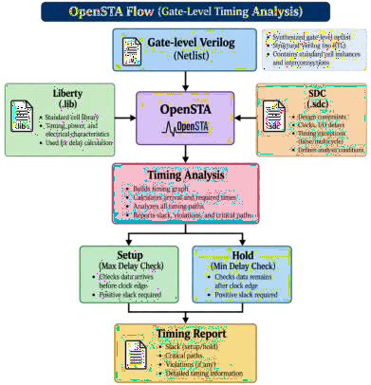
For post-route timing:
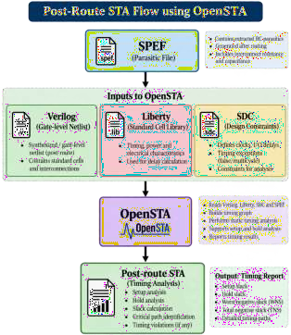

RUNNING OPENSTA WITH A TCL SCRIPT
Instead of entering commands one by one, create a script.
  - gvim run_sta.tcl Example:
  - read_liberty <standard_cell.lib>

  - read_verilog synthesized_netlist.v

  - link_design <TOP_MODULE>

  - read_sdc constraints.sdc

  - report_clocks

  - check_setup

  - report_checks -path_delay max

  - report_checks -path_delay min Run:
  - opensta run_sta.tcl
or:
  - sta run_sta.tcl
depending on the installed executable.

SAVE THE TIMING REPORT
Timing output can be redirected from the Linux shell:
  - opensta run_sta.tcl > timing_report.txt Then inspect:
  - gvim timing_report.txt
or:
  - cat timing_report.txt

EXAMPLE TIMING ANALYSIS
Consider:
Clock Period = 10.0 ns Clock Uncertainty = 0.2 ns Data Arrival = 8.1 ns Required Time = 9.8 ns

Therefore:

𝑆𝑙𝑎𝑐𝑘 = 9.8 − 8.1
𝑆𝑙𝑎𝑐𝑘 = +1.7𝑛𝑠

Hence:
Setup Timing → PASS If:
Arrival Time = 10.3 ns Required Time = 9.8 ns then:

𝑆𝑙𝑎𝑐𝑘 = 9.8 − 10.3
𝑆𝑙𝑎𝑐𝑘 = −0.5𝑛𝑠

Therefore:
Setup Timing → FAIL

SETUP AND HOLD ANALYSIS

Analysis | OpenSTA Command | Purpose
Setup / Max | report_checks -path_delay max | Checks maximum data delay
Hold / Min | report_checks -path_delay min | Checks minimum data delay
Clock | report_clocks | Reports clock information
Setup checks | check_setup | Checks timing setup
Detailed timing | report_timing | Reports timing path information

IMPORTANT TIMING TERMS

Term | Meaning
Startpoint | Beginning of a timing path
Endpoint | End of a timing path
Arrival Time | Time at which data reaches endpoint
Required Time | Latest/earliest allowed arrival depending on analysis
Slack | Difference between required and arrival time
WNS | Worst Negative Slack
TNS | Total Negative Slack
Slew | Transition time of a signal
Fanout | Number of loads driven by a pin
Capacitance | Load seen by a driver
Clock Skew | Difference between clock arrival times
Clock Uncertainty | Timing margin representing clock variation/uncertainty

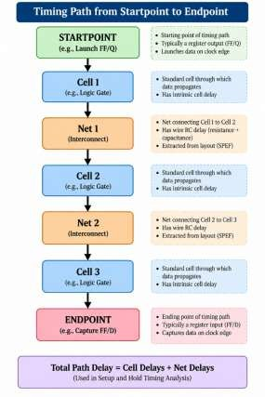
TIMING PATH ANALYSIS
A typical path can be represented as:

PRE-ROUTE AND POST-ROUTE STA

Pre-route STA
Before routing:

Netlist
+
Liberty

+ SDC

↓ OpenSTA
↓

Pre-route timing

Wire parasitics may be estimated or represented differently depending on the flow.

Post-route STA
After routing:
Routed Design
│
▼
Parasitic Extraction
│
▼
SPEF
│
▼
OpenSTA
│
▼
Post-route Timing
Post-route STA is important for final timing verification because actual routing parasitics can significantly affect delay.

40. ANALYSIS

39. OBSERVATION TABLE

S.No. | Parameter | Observation
1  2  3  4  5  6  7  8  9  10  11  12  13  14 | OpenSTA Version
1  2  3  4  5  6  7  8  9  10  11  12  13  14 | Top Module
1  2  3  4  5  6  7  8  9  10  11  12  13  14 | Liberty File
1  2  3  4  5  6  7  8  9  10  11  12  13  14 | Netlist
1  2  3  4  5  6  7  8  9  10  11  12  13  14 | SDC File
1  2  3  4  5  6  7  8  9  10  11  12  13  14 | Clock Name
1  2  3  4  5  6  7  8  9  10  11  12  13  14 | Clock Period
1  2  3  4  5  6  7  8  9  10  11  12  13  14 | Setup WNS
1  2  3  4  5  6  7  8  9  10  11  12  13  14 | Setup TNS
1  2  3  4  5  6  7  8  9  10  11  12  13  14 | Hold WNS
1  2  3  4  5  6  7  8  9  10  11  12  13  14 | Hold TNS
1  2  3  4  5  6  7  8  9  10  11  12  13  14 | Critical Startpoint
1  2  3  4  5  6  7  8  9  10  11  12  13  14 | Critical Endpoint
1  2  3  4  5  6  7  8  9  10  11  12  13  14 | Timing Status | PASS / FAIL

41. EXPECTED OUTPUT

42. RESULT

45. CONCLUSION

EXPERIMENT–9
Perform the Detailed Placement Analysis Using OpenDP
Contact Hours: 2 Hours

AIM
To study and perform detailed placement of standard cells using OpenDP, understand the detailed placement optimization process, and analyze the placement quality with respect to legality, cell overlap, displacement, congestion, and timing.
Note: In current OpenROAD releases, the detailed placement functionality is provided by the dpl module. It is based on the OpenDP detailed-placement engine. Therefore, the syllabus term OpenDP corresponds to the current OpenROAD detailed-placement flow using commands such as detailed_placement.

OBJECTIVES
After completing this experiment, the student should be able to:
- Understand the concept of placement in ASIC physical design.
- Differentiate between global placement and detailed placement.
- Understand the purpose of OpenDP.
- Perform detailed placement using OpenROAD.
- Detect and resolve:
  - Cell overlaps
  - Illegal cell locations
  - Row misalignment
  - Placement violations
- Analyze cell displacement after legalization.
- Verify placement using OpenROAD checks.
- Understand the effect of detailed placement on: a. Timing
- Wirelength
- Congestion
- Placement legality
- Generate a legalized placement database and DEF file.

SOFTWARE / TOOLS REQUIRED

S.No. | Software / File | Purpose
1  2  3  4 | Linux / Ubuntu | Operating environment
1  2  3  4 | OpenROAD | Physical design implementation
1  2  3  4 | OpenDP | Detailed placement engine
1  2  3  4 | OpenDB | Physical design database

S.No.  5  6  7  8  9  10 | Software / File | Purpose
S.No.  5  6  7  8  9  10 | Yosys | RTL synthesis
S.No.  5  6  7  8  9  10 | LEF | Physical library information
S.No.  5  6  7  8  9  10 | Liberty .lib | Timing information
S.No.  5  6  7  8  9  10 | Verilog netlist | Gate-level connectivity
S.No.  5  6  7  8  9  10 | DEF | Physical placement information
S.No.  5  6  7  8  9  10 | ODB | OpenROAD database

THEORY
  - What is Placement?
Placement is the process of determining the physical locations of standard cells and macros inside the chip's core area.
After synthesis, the design consists of logical cells:

RTL
│
▼

Synthesis
│
▼

Gate-Level Netlist
│
▼

Placement
│
▼

Physical Locations

The placement stage determines where each cell will physically reside.

PLACEMENT IN ASIC PHYSICAL DESIGN
A simplified physical-design flow is:

Synthesized Netlist
│
▼
Floorplanning
│
▼
Global Placement
│
▼
Detailed Placement
│
▼
CTS
│
▼
Routing
│
▼
Sign-off

Detailed placement occurs after global placement and before clock-tree synthesis.

GLOBAL PLACEMENT VS DETAILED PLACEMENT

Global Placement
Global placement determines approximate locations for cells. It focuses primarily on:
- Wirelength
- Density
- Timing
- Congestion
- Placement distribution
Cells may temporarily overlap during this stage.

Detailed Placement
Detailed placement takes the globally placed cells and moves them into legal locations. It attempts to ensure:
- No cell overlap
- Cells are aligned to legal rows
- Cells satisfy placement-site requirements
- Cells remain inside legal regions
- Cell displacement is minimized

WHAT IS OpenDP?
OpenDP is a detailed-placement engine used to legalize and optimize the placement of standard cells. In current OpenROAD, the detailed-placement functionality is exposed through the DPL (dpl) module. Its major responsibilities include:
- Placement legalization
- Cell overlap removal
- Row alignment
- Cell displacement minimization
- Placement optimization
- Placement legality verification

WHY DETAILED PLACEMENT IS REQUIRED
- Global placement can produce a solution that is approximately optimal but physically illegal.
- Detailed placement converts this into:

PLACEMENT LEGALITY
A standard cell placement is considered legal when cells satisfy the physical placement rules of the technology.
Important conditions include:

No overlap
Two standard cells should not occupy the same physical area.

Row alignment
Cells must be aligned with legal standard-cell rows.

Site alignment
Cell locations must correspond to legal placement sites.

Core boundary
Cells must remain inside the legal placement area.

Placement blockages
Cells must not be placed in prohibited regions.

INPUTS FOR DETAILED PLACEMENT
Detailed placement generally requires a previously initialized and globally placed design. Typical inputs include:
LEF
│
▼
Netlist ───► OpenROAD ◄─── Liberty
│
▼
Floorplan
│
▼
Global Placement
│
▼
Detailed Placement

Typical files:

File | Information
.lef  .lib  .v  .def  .odb | Physical cell/macros and technology information
.lef  .lib  .v  .def  .odb | Cell timing and electrical characteristics
.lef  .lib  .v  .def  .odb | Gate-level connectivity
.lef  .lib  .v  .def  .odb | Physical design information
.lef  .lib  .v  .def  .odb | OpenROAD database

- PLACEMENT QUALITY PARAMETERS
Detailed placement can be analyzed using several parameters.
  - Cell Displacement
Cell displacement is the distance a cell moves from its original global-placement location. Global position Legal position
The objective is generally to legalize the design with minimal unnecessary displacement.
  - Wirelength
Placement affects the distance between connected cells. Cell A ─────────────── Cell B
Wirelength

Excessive wirelength can increase:
    - Delay
    - Power
    - Routing congestion
  - Congestion
Poor placement can cause routing congestion. Low congestion:
High congestion:
  - Timing
Cell locations influence:
    - Net delay
    - Slew
    - Setup timing
    - Hold timing
Therefore, detailed placement may be followed by timing analysis.
- PROCEDURE
Step 1 – Check OpenROAD Installation
Run:
- openroad -version
You can also start the OpenROAD shell:
- openroad Then:
- version
- Step 2 – Prepare the Experiment Directory
- mkdir -p ~/openroad_exp9
- cd ~/openroad_exp9

- Step 3 – Obtain the Placed Design
For this experiment, start with a design that has already undergone:
- Floorplan initialization
- Power planning
- Global placement For example:
floorplan.odb
│
▼
PDN
│
▼
Global Placement
│
▼
global_placed.odb
If using the previous experiment flow, use the corresponding placed database generated by your OpenROAD flow.
- Step 4 – Read the Design Database
Start OpenROAD:
- openroad
Read the placed database:
- read_db global_placed.odb Check the design:
- report_design_area

- Step 5 – Check the Current Placement
Before detailed placement, run:
- check_placement
This helps identify placement legality problems. Typical issues may include:
- Cell overlap
- Out-of-bound cells
- Illegal locations
- Row/site alignment issues

- Step 6 – Inspect the Placement
Launch the OpenROAD GUI:
- gui::show
Depending on the OpenROAD version, you can also use:
- gui Inspect:
- Core area
- Standard-cell rows
- Cell distribution
- Macros
- Placement density
- Overlapping cells
- Blockages
- Step 7 – Perform Detailed Placement
Run:
- detailed_placement
This invokes the current OpenROAD detailed-placement functionality based on OpenDP. The engine attempts to legalize the placement by moving cells to valid locations.
- STEP 8 – Check Placement Again
After detailed placement:
- check_placement
Compare the results before and after detailed placement. Before:

check_placement
│
▼
Placement violations
│
▼
detailed_placement
│
▼
check_placement
│
▼
Legal placement

- STEP 9 – Optimize Detailed Placement
OpenROAD provides placement optimization capabilities that can be used to improve timing and/or placement quality after legalization.
A representative command is:
- improve_placement
Depending on the design and OpenROAD version, optimization options may be available for timing and placement objectives.
For example, inspect available options with:
- help improve_placement
- STEP 10 – Analyze Timing After Placement
If timing constraints are loaded, run:
- report_checks -path_delay max For hold:
- report_checks -path_delay min Record:
- Setup WNS
- Setup TNS
- Hold WNS
- Hold TNS
Compare timing before and after detailed placement.
- STEP 11 – Analyze Placement Area
Run:
- report_design_area Record:
- Core area
- Die area
- Standard-cell area
- Utilization

- STEP 12 – Save the Detailed Placement
Save the legalized database:
- write_db detailed_placement.odb Save the DEF:
- write_def detailed_placement.def
These files can be used in subsequent stages.

- COMPLETE REPRESENTATIVE OPENROAD SCRIPT
Create a Tcl script:
- gvim exp9_detailed_placement.tcl Example:
- read_db global_placed.odb

- report_design_area

- check_placement
- detailed_placement

- check_placement

- report_design_area
- report_checks -path_delay max

- report_checks -path_delay min

- write_db detailed_placement.odb
- write_def detailed_placement.def Run:
- openroad exp9_detailed_placement.tcl
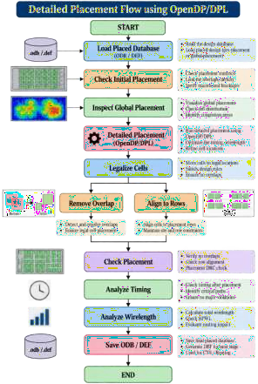
The exact input database name, timing setup, and optimization commands depend on the design and OpenROAD flow being used.
- DETAILED PLACEMENT FLOW

- BEFORE AND AFTER DETAILED PLACEMENT
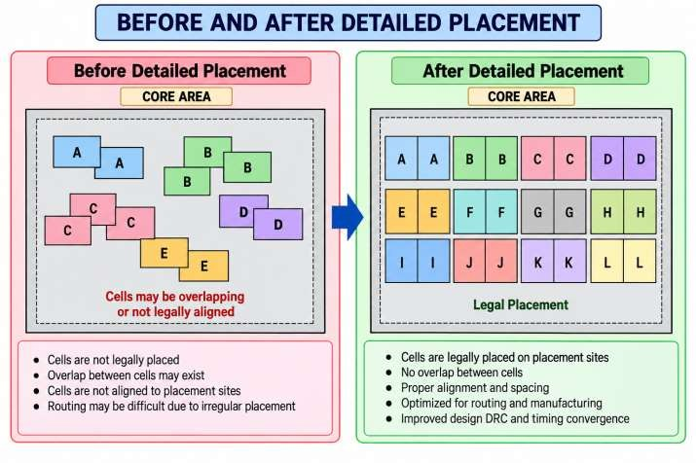
- OBSERVATION TABLE

S.No. | Parameter | Before Detailed Placement | After Detailed Placement
1  2  3  4  5  6  7  8  9  10 | Design Name
1  2  3  4  5  6  7  8  9  10 | Core Area
1  2  3  4  5  6  7  8  9  10 | Die Area
1  2  3  4  5  6  7  8  9  10 | Utilization
1  2  3  4  5  6  7  8  9  10 | Placement Status
1  2  3  4  5  6  7  8  9  10 | Cell Overlap
1  2  3  4  5  6  7  8  9  10 | Row Alignment
1  2  3  4  5  6  7  8  9  10 | Setup WNS
1  2  3  4  5  6  7  8  9  10 | Setup TNS
1  2  3  4  5  6  7  8  9  10 | Hold WNS

S.No. | Parameter | Before Detailed Placement | After Detailed Placement
11  12 | Hold TNS
11  12 | Placement Quality

- ANALYSIS

- EXPECTED OUTPUT

- IMPORTANT OPENROAD COMMANDS

Command | Purpose
read_db | Read OpenROAD database
report_design_area | Report design area and utilization
check_placement | Check placement legality
detailed_placement | Perform detailed placement/legalization
improve_placement | Improve placement quality
report_checks | Analyze timing
write_db | Save OpenROAD database
write_def | Write DEF
gui::show | Display GUI
help detailed_placement | Display command help

- ROLE OF DETAILED PLACEMENT IN THE ASIC FLOW
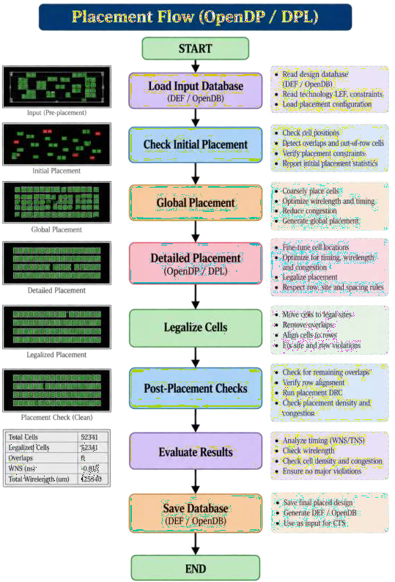

Detailed placement is therefore the bridge between global placement and clock-tree synthesis.

- EFFECT OF DETAILED PLACEMENT

Parameter | Effect of Detailed Placement
Cell overlap | Reduced/removed
Placement legality | Improved
Row alignment | Corrected
Cell displacement | Minimized where possible
Wirelength | Can change
Congestion | Can improve or worsen depending on movement
Timing | Can improve or degrade
Routing readiness | Improved
CTS readiness | Improved

- RESULT

- CONCLUSION

EXPERIMENT–10
Analyze Clock Tree Synthesis Using TritonCTS 2.0 Contact Hours: 2 Hours
- AIM
To study and perform Clock Tree Synthesis (CTS) using TritonCTS 2.0 in OpenROAD, and to analyze clock-tree characteristics such as clock skew, insertion delay, clock latency, buffer insertion, clock-tree structure, and timing impact.
- OBJECTIVES
After completing this experiment, the student should be able to:
- Understand the purpose of Clock Tree Synthesis.
- Understand the problems associated with clock distribution.
- Study the architecture of a clock tree.
- Understand TritonCTS 2.0.
- Perform CTS using OpenROAD.
- Analyze:
  - Clock insertion delay
  - Clock skew
  - Clock latency
  - Clock-tree buffering
  - Clock fanout
- Generate clock-tree reports.
- Analyze timing before and after CTS.
- Understand the importance of CTS before routing.
- Save the CTS database for subsequent routing stages.

- SOFTWARE / TOOLS REQUIRED

S.No. | Software / File | Purpose
1  2  3  4  5  6  7  8  9 | Linux / Ubuntu | Operating environment
1  2  3  4  5  6  7  8  9 | OpenROAD | Physical design implementation
1  2  3  4  5  6  7  8  9 | TritonCTS 2.0 | Clock Tree Synthesis
1  2  3  4  5  6  7  8  9 | OpenDB | Physical design database
1  2  3  4  5  6  7  8  9 | OpenSTA | Static timing analysis
1  2  3  4  5  6  7  8  9 | LEF | Physical cell information
1  2  3  4  5  6  7  8  9 | Liberty .lib | Timing and cell information
1  2  3  4  5  6  7  8  9 | Verilog | Gate-level netlist
1  2  3  4  5  6  7  8  9 | SDC | Clock and timing constraints

S.No.  10 | Software / File | Purpose
S.No.  10 | DEF / ODB | Physical design database

- THEORY
  - What is Clock Tree Synthesis?
Clock Tree Synthesis (CTS) is the process of creating a physical clock-distribution network that delivers the clock signal from its source to all required sequential elements.
A clock network typically contains:
    - Clock source
    - Clock buffers
    - Clock inverters
    - Clock branches
    - Flip-flop clock pins Simplified structure:
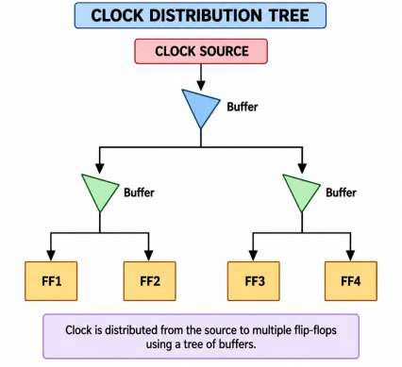

The objective is to distribute the clock with acceptable:
    - Skew
    - Insertion delay
    - Slew
    - Fanout
    - Power

- WHY IS CTS REQUIRED?
Before CTS, a synthesized design may contain a clock net connected directly to many flip-flops. For example:
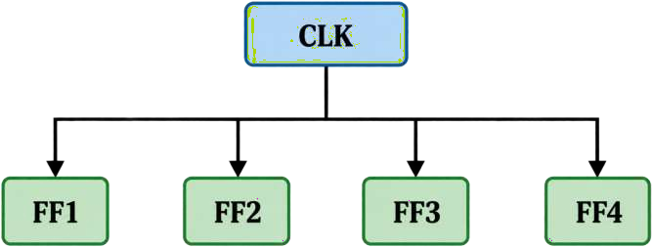

This is not an ideal physical clock network because:
- Fanout can be very high.
- Wire lengths differ.
- Clock arrival times differ.
- Signal transition can become slow.
- Timing violations can occur.
CTS converts the clock network into a buffered tree:
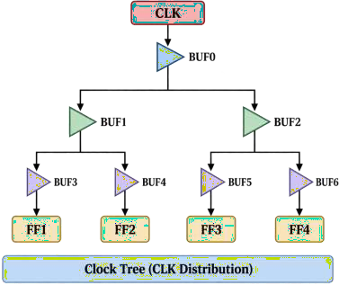

- CLOCK TREE OBJECTIVES
The major objectives of CTS are:
- Minimize Clock Skew
Clock skew should be kept as small as possible.
- Control Clock Insertion Delay
The time taken for the clock to travel from source to sink should be controlled.
- Control Slew
The clock transition should remain within acceptable limits.
- Manage Fanout
A single clock buffer should not drive an excessive number of loads.
- Maintain Timing
CTS should help the design satisfy setup and hold timing requirements.
- Control Power
Clock networks can consume significant dynamic power, so excessive buffering should be avoided

- CLOCK SKEW
Clock skew is the difference between clock arrival times at two sequential elements. For example:
Clock arrival at FF1 = 1.20 ns Clock arrival at FF2 = 1.35 ns Therefore:
𝑆𝑘𝑒𝑤 = 1.35 − 1.20
𝑆𝑘𝑒𝑤 = 0.15𝑛𝑠

The objective of CTS is generally to minimize undesirable skew.
- CLOCK INSERTION DELAY
Clock insertion delay, also called clock latency, represents the delay from the clock source to a clock sink.
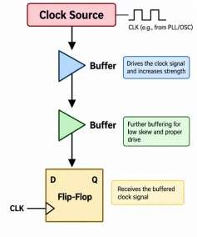

If:
Buffer delay = 0.2 ns Buffer delay = 0.3 ns Wire delay = 0.2 ns Then approximately:
𝐼𝑛𝑠𝑒𝑟𝑡𝑖𝑜𝑛 𝐷𝑒𝑙𝑎𝑦 = 0.2 + 0.3 + 0.2
= 0.7𝑛𝑠
- CLOCK JITTER
Clock jitter is the variation in the timing of a clock edge relative to its ideal position.
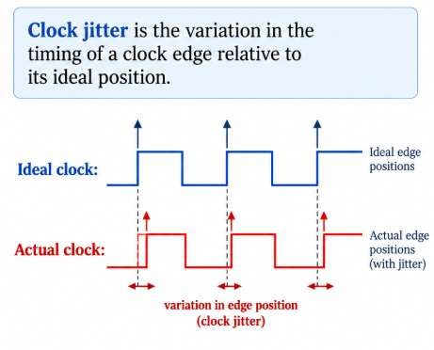

Clock uncertainty in timing constraints can account for clock-related variations. Example:
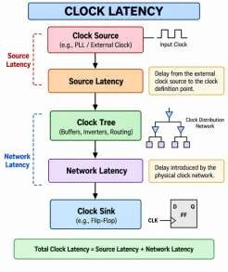
set_clock_uncertainty 0.2 [get_clocks clk]
- CLOCK LATENCY
Clock latency can be divided conceptually into:
Source Latency
Delay from the external clock source to the clock definition point.
Network Latency
Delay introduced by the physical clock network.

- CLOCK TREE STRUCTURES
Common clock-tree structures include:
  - Balanced Tree
  - H-Tree
  - Clock Mesh

A mesh uses multiple interconnected clock wires and can provide low skew but generally has greater routing and power cost.
TritonCTS primarily constructs a buffered clock tree rather than a conventional full clock mesh.

- WHAT IS TRITONCTS 2.0?
TritonCTS 2.0 is the clock-tree synthesis engine used in the OpenROAD project.
It performs clock-tree construction by inserting clock buffers and creating a clock distribution network between clock sources and sinks.
In current OpenROAD, CTS is invoked using:
  - clock_tree_synthesis
The CTS module is based on the TritonCTS 2.0 technology.
- INPUTS REQUIRED FOR CTS

Important information includes:
  - Placed standard cells
  - Clock definitions
  - Clock source
  - Clock sinks
  - Available clock buffers
  - Liberty timing information
  - Technology LEF
  - Routing information
Typical CTS inputs are: LEF
│
▼
Netlist ─────► OpenROAD ◄──── Liberty
│
▲
│ SDC
│
▼
Placed Design
│
▼
CTS

- PROCEDURE
Step 1 – Check OpenROAD Version
Run:
  - openroad -version Start OpenROAD:
  - openroad Check:
  - version

- STEP 2 – Check CTS Command
Inside OpenROAD:
  - help clock_tree_synthesis
This displays the CTS command and the options supported by the installed OpenROAD version.
- STEP 3 – Create Experiment Directory
  - mkdir -p ~/openroad_exp10
  - cd ~/openroad_exp10
- STEP 4 – Load the Detailed-Placed Database
Use the database generated after Experiment-9:
  - read_db detailed_placement.odb Check the design:
  - report_design_area
- STEP 5 – Check Placement
Before CTS, ensure the design has a legal placement:
  - check_placement
The design should not have major placement violations.
- STEP 6 – Check Clock Definitions
If the SDC has already been loaded into the database, inspect the clocks:
  - report_clocks You should identify:
  - Clock name
  - Clock period
  - Clock source
  - Clock waveform For example:
Clock name : clk Clock period : 10 ns

- STEP 7 – Load Timing Information if Required
If starting from a database that does not contain all required timing information, load the relevant Liberty and constraints:
  - read_liberty <standard_cell.lib> Then:
  - read_sdc <constraints.sdc>
The exact setup depends on how the input ODB was generated.
- STEP 8 – Configure CTS Buffer Cells
TritonCTS requires appropriate clock-buffer cells. A representative command is:

set_clock_tree_options \
-buffer_list {CLKBUF_X1 CLKBUF_X2 CLKBUF_X4}

The actual clock-buffer cell names must exist in your technology library. For example, a PDK may provide cells such as:
  - CLKBUF_X1
  - CLKBUF_X2
  - CLKBUF_X4
  - CLKINV_X1
  - CLKINV_X2
Always check the actual Liberty/LEF library before using these names.

- STEP 9 – Perform Clock Tree Synthesis
Run:
  - clock_tree_synthesis
TritonCTS analyzes the clock network and inserts the required clock-tree buffers. The conceptual operation is:
Clock Source
│
▼
Clock Sinks
│
▼
Determine topology
│
▼
Insert clock buffers
│
▼
Balance clock paths
│
▼
Generate clock tree

- STEP 10 – Useful CTS Options
The exact options available depend on the installed OpenROAD version. Check them using:
  - help clock_tree_synthesis Common CTS concepts/options include:
  - clock_tree_synthesis
  - -buffer_list
  - -root_buf
  - -wire_unit
  - -obstruction_aware
  - -delay_buffer_derate
Do not copy technology-specific values blindly; use the command help and the PDK configuration.
- STEP 11 – Analyze the Clock Tree After CTS, inspect the clock network. Run:
  - report_clock_skew
This report is useful for analyzing clock arrival differences. You can also use:
  - report_cts
if supported by your OpenROAD version. Check available reporting commands:
  - help report_cts
  - help report_clock_skew

- STEP 12 – Analyze Timing After CTS
Run maximum-delay timing analysis:
  - report_checks -path_delay max For minimum-delay analysis:
  - report_checks -path_delay min Record:
  - Setup WNS
  - Setup TNS
  - Hold WNS
  - Hold TNS

- STEP 13 – Analyze Clock Paths
A timing path after CTS contains clock-tree delays. Conceptually:

Different branches may have different delays. CTS attempts to balance these paths.
- STEP 14 – Inspect CTS in GUI
Launch the GUI:
  - gui::show Inspect:
  - Clock source
  - Clock buffers
  - Clock branches
  - Flip-flop clock pins
  - Clock-tree topology
  - Cell locations
The clock tree should appear as a branching network connecting the clock source to sequential sinks.

- STEP 15 – Check Placement After CTS
Run:
  - check_placement
CTS inserts new cells, so it is useful to verify that the resulting placement remains legal.
- STEP 16 – Save the CTS Database
Save the OpenROAD database:
  - write_db cts.odb Save the DEF:
  - write_def cts.def
These files are used by later routing stages.
- COMPLETE REPRESENTATIVE CTS SCRIPT
Create:
  - gvim exp10_cts.tcl
Use a technology-specific configuration similar to: read_db detailed_placement.odb
report_design_area

check_placement

report_clocks

set_clock_tree_options \
-buffer_list {CLKBUF_X1 CLKBUF_X2 CLKBUF_X4} clock_tree_synthesis
check_placement report_clock_skew
report_checks -path_delay max report_checks -path_delay min
write_db cts.odb write_def cts.def Run:
  - openroad exp10_cts.tcl
Important: CLKBUF_X1, CLKBUF_X2, and CLKBUF_X4 are example names. Replace them with clock-buffer cells available in your technology library.
- BEFORE CTS and AFTER CTS
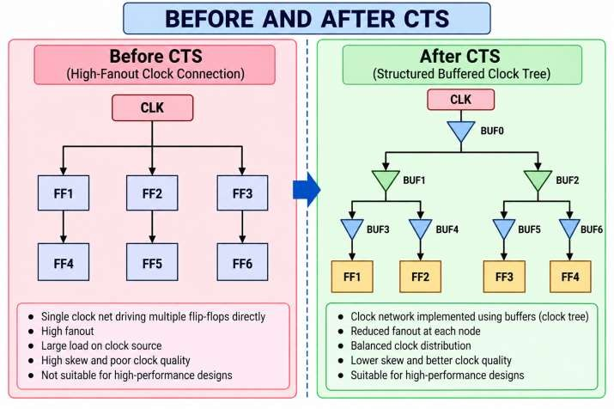

34. CLOCK SKEW ANALYSIS

Suppose:
Clock arrival at FF1 = 1.25 ns Clock arrival at FF2 = 1.30 ns Clock arrival at FF3 = 1.28 ns Clock arrival at FF4 = 1.27 ns Maximum arrival time:

1.30𝑛𝑠

Minimum arrival time:
1.25𝑛𝑠

Therefore:

𝐶𝑙𝑜𝑐𝑘 𝑆𝑘𝑒𝑤 = 1.30 − 1.25
𝐶𝑙𝑜𝑐𝑘 𝑆𝑘𝑒𝑤 = 0.05𝑛𝑠

Thus the clock skew is:
0.05 ns = 50 ps

- CLOCK TREE QUALITY PARAMETERS

Parameter | Description | Desired Behavior
Clock Skew | Difference in clock arrival times | Low
Insertion Delay | Source-to-sink clock delay | Controlled
Clock Slew | Clock transition time | Within limits
Fanout | Number of loads driven | Controlled
Buffer Count | Number of inserted clock cells | Optimized
Clock Power | Power consumed by clock network | Low
Timing Slack | Timing margin | Positive
Clock Balance | Similarity of branch delays | High

- OBSERVATION TABLE

S.No. | Parameter | Before CTS | After CTS
1  2  3 | Design Name
1  2  3 | Clock Name
1  2  3 | Clock Period

S.No.  4  5  6  7  8  9  10  11  12  13 | Parameter | Before CTS | After CTS
S.No.  4  5  6  7  8  9  10  11  12  13 | Number of Clock Sinks
S.No.  4  5  6  7  8  9  10  11  12  13 | Clock Buffers
S.No.  4  5  6  7  8  9  10  11  12  13 | Clock Insertion Delay
S.No.  4  5  6  7  8  9  10  11  12  13 | Clock Skew
S.No.  4  5  6  7  8  9  10  11  12  13 | Maximum Clock Slew
S.No.  4  5  6  7  8  9  10  11  12  13 | Setup WNS
S.No.  4  5  6  7  8  9  10  11  12  13 | Setup TNS
S.No.  4  5  6  7  8  9  10  11  12  13 | Hold WNS
S.No.  4  5  6  7  8  9  10  11  12  13 | Hold TNS
S.No.  4  5  6  7  8  9  10  11  12  13 | Placement Status

- ANALYSIS

- EXPECTED OUTPUT

37. RESULT

EXPERIMENT–11
Perform Global Routing Using TritonRoute and Do Analysis of Design
Contact Hours: 2 Hours
- AIM
To study the routing process in ASIC physical design, perform global routing using OpenROAD, understand the role of TritonRoute in detailed routing, and analyze routing quality using parameters such as wirelength, congestion, routing guides, design-rule violations, and timing.

- OBJECTIVES
After completing this experiment, the student should be able to:
- Understand the concept of routing in ASIC physical design.
- Understand the difference between:
  - Global routing
  - Detailed routing
- Understand the role of FastRoute in OpenROAD global routing.
- Understand the role of TritonRoute in detailed routing.
- Perform global routing using global_route.
- Generate routing guides.
- Perform detailed routing using detailed_route.
- Analyze:
  - Routing congestion
  - Wirelength
  - Routing resources
  - Design-rule violations
  - Antenna-related issues
  - Timing after routing
- Save the routed design in ODB and DEF formats.
- Understand how routing affects post-route timing.
- SOFTWARE / TOOLS REQUIRED

S.No. | Software / File | Purpose
1  2  3  4  5  6  7  8  9 | Linux / Ubuntu | Operating environment
1  2  3  4  5  6  7  8  9 | OpenROAD | Physical implementation
1  2  3  4  5  6  7  8  9 | FastRoute | Global routing engine
1  2  3  4  5  6  7  8  9 | TritonRoute | Detailed routing engine
1  2  3  4  5  6  7  8  9 | OpenDB | Design database
1  2  3  4  5  6  7  8  9 | OpenSTA | Timing analysis
1  2  3  4  5  6  7  8  9 | LEF | Technology and physical-cell information
1  2  3  4  5  6  7  8  9 | Liberty .lib | Cell timing information
1  2  3  4  5  6  7  8  9 | Verilog | Gate-level netlist

S.No.  10  11  12 | Software / File | Purpose
S.No.  10  11  12 | SDC | Timing constraints
S.No.  10  11  12 | DEF | Physical design representation
S.No.  10  11  12 | ODB | OpenROAD database

- THEORY
  - What is Routing?
Routing is the process of creating physical metal connections between the pins of cells according to the logical connectivity specified by the netlist.
After placement and CTS, the design contains physically positioned cells but the signal nets still need to be connected.
n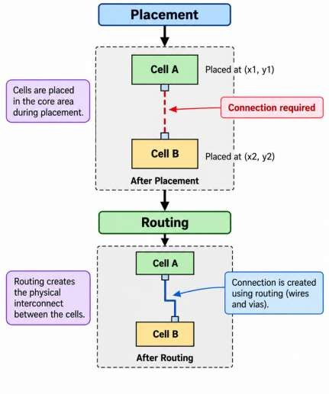 Routing creates the actual physical metal paths.

- ROUTING IN THE ASIC FLOW
The routing stage follows CTS.
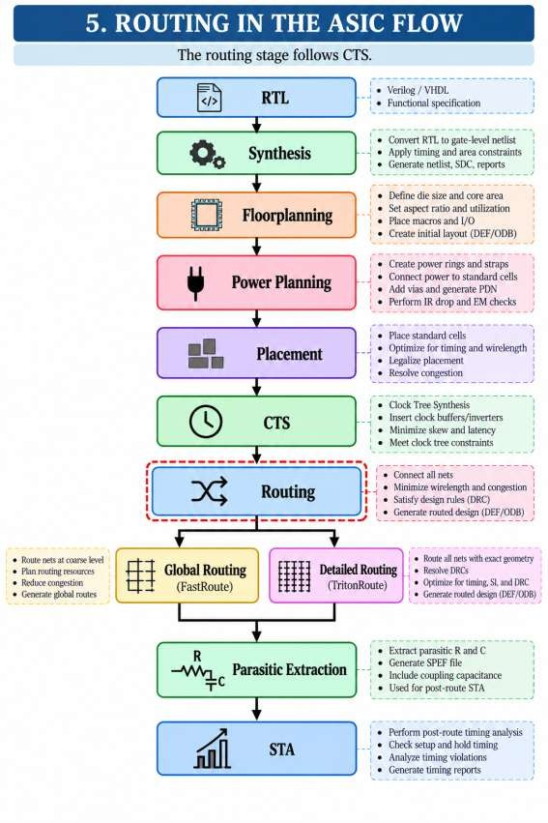

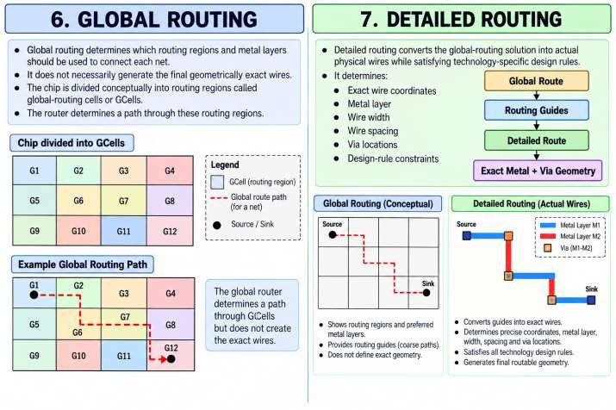
- GLOBAL ROUTING
Global routing determines which routing regions and metal layers should be used to connect each net. It does not necessarily generate the final geometrically exact wires.
The chip is divided conceptually into routing regions called global-routing cells or GCells. The router determines a path through these routing regions.
- DETAILED ROUTING
Detailed routing converts the global-routing solution into actual physical wires while satisfying technology-specific design rules.
It determines:
- Exact wire coordinates
- Metal layer
- Wire width
- Wire spacing
- Via locations
- Design-rule constraints

- FASTROUTE AND TRITONROUTE
FastRoute
OpenROAD's current global-routing stage uses the FastRoute-based grt module. Command:
- global_route Its purpose is to:
- Estimate routing paths
- Generate routing guides
- Analyze congestion
- Assign routing resources
TritonRoute
TritonRoute is OpenROAD's detailed-routing engine. The current command is:
detailed_route
It creates detailed physical routing while considering design rules. Therefore:
Global Routing
│
▼
FastRoute / GRT
│
▼
Routing Guides
│
▼
TritonRoute / DRT
│
▼
Detailed Routing

- ROUTING OBJECTIVES
The major objectives of routing are:
- Complete Connectivity
All required nets should be connected.
- Minimize Wirelength
Shorter wires generally reduce:
  - Delay
  - Capacitance
  - Power
- Minimize Congestion
Routing resources should be distributed efficiently.
- Satisfy Design Rules

The routing must satisfy:
  - Minimum width
  - Minimum spacing
  - Via rules
  - Metal rules
  - End-of-line rules
- Meet Timing
Routing should preserve or improve timing closure.
- Minimize Power
Long interconnects and excessive capacitance can increase dynamic power.

- ROUTING LAYERS
Modern ASICs contain multiple metal layers.
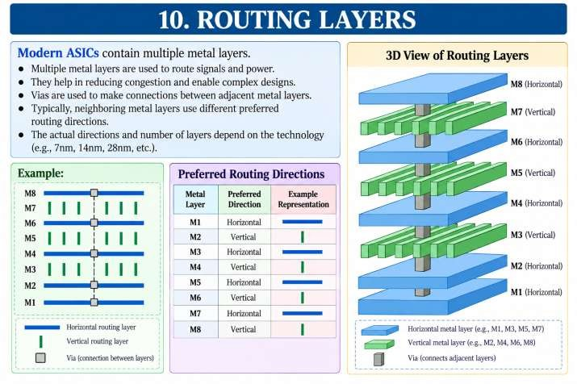

- VIAS
A via provides a connection between different metal layers.
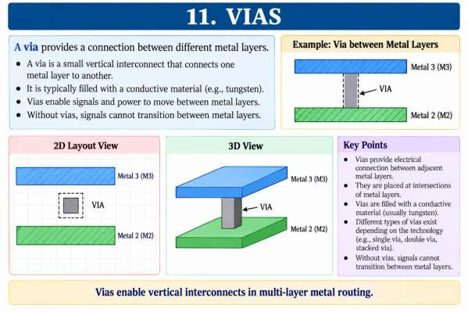
- ROUTING CONGESTION
Routing congestion occurs when routing demand exceeds the available routing resources.
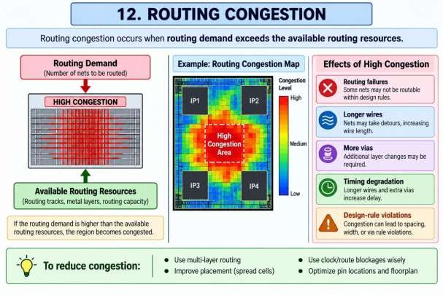

- ROUTING CAPACITY
Routing capacity represents the available routing resources in a region. Conceptually:

𝐶𝑜𝑛𝑔𝑒𝑠𝑡𝑖𝑜𝑛 =
𝑅𝑜𝑢𝑡𝑖𝑛𝑔 𝐷𝑒𝑚𝑎𝑛𝑑

𝑅𝑜𝑢𝑡𝑖𝑛𝑔 𝐶𝑎𝑝𝑎𝑐𝑖𝑡𝑦

If:
𝐷𝑒𝑚𝑎𝑛𝑑 < 𝐶𝑎𝑝𝑎𝑐𝑖𝑡𝑦

the region is generally routable. If:
𝐷𝑒𝑚𝑎𝑛𝑑 > 𝐶𝑎𝑝𝑎𝑐𝑖𝑡𝑦

the region is congested.

- ROUTING GUIDES
Global routing produces routing guides that indicate where detailed routing should occur. Conceptually:
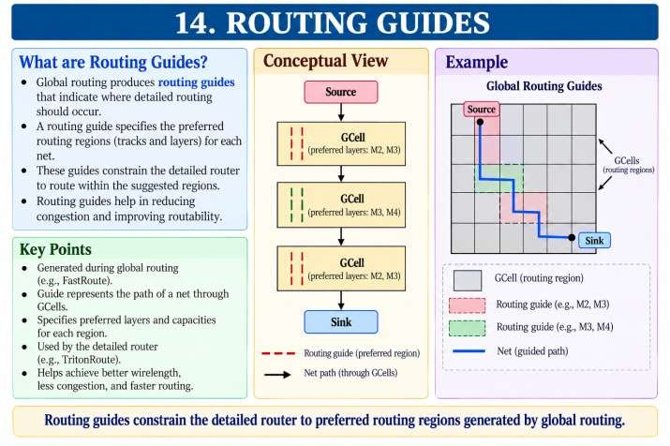

- INPUTS FOR ROUTING
The routing stage typically requires:
LEF
│
▼
OpenROAD
▲
│
┌──────┼──────┐

ODB LIB SDC
│
▼
CTS Design
│
▼
Routing
Important information includes:
- Routed/unrouted nets
- Cell locations
- Pin locations
- Routing layers
- Routing blockages
- Technology design rules
- Clock network
- Timing constraints

- STEP 2 – Check Routing Commands
Inside OpenROAD:
  - help global_route For detailed routing:
  - help detailed_route
This is important because routing options can vary between OpenROAD versions.
- STEP 3 – Create Experiment Directory
  - mkdir -p ~/openroad_exp11
  - cd ~/openroad_exp11

- STEP 4 – Load CTS Database
Use the output generated from Experiment-10:
  - read_db cts.odb Check placement:
  - check_placement Report area:
  - report_design_area
- STEP 5 – Inspect the Design Before Routing
Open the GUI:
  - gui::show Inspect:
  - Standard cells
  - Macros
  - Clock-tree buffers
  - Signal pins
  - Routing blockages
  - Power network
At this stage, many signal nets are still unrouted.
- STEP 6 – Check Clock Information
Run:
  - report_clocks Analyze:
  - Clock period
  - Clock name
  - Clock source
  - Clock sinks

- STEP 7 – Perform Global Routing
Run:
  - global_route
The global router determines routing paths through routing resources.

Conceptually:
Global Route
│
▼
Divide into GCells
│
▼
Estimate routing demand
│
▼
Allocate routing layers
│
▼
Generate route guides

- STEP 8 – Generate Routing Guides
A representative routing flow can write guides using:
  - write_guides route.guide
The resulting guide file describes the routing regions generated by global routing.
- STEP 9 – Analyze Routing Congestion After global routing, analyze congestion. Depending on the OpenROAD version, use:
  - global_route -congestion_report_file congestion.rpt A representative command may therefore be:
global_route \
-congestion_report_file congestion.rpt Inspect:
  - gvim congestion.rpt
or:
  - cat congestion.rpt
The exact options should be verified using:
  - help global_route

- STEP 10 – Analyze Global Routing
Important parameters include:
  - Total wirelength
  - Routing overflow
  - Horizontal overflow
  - Vertical overflow
  - Routing demand
  - Routing capacity A desirable result is:
  - Routing Overflow → Low / Zero

- STEP 11 – Perform Detailed Routing
After global routing, detailed routing can be performed using:
  - detailed_route
This invokes the current OpenROAD detailed-routing engine based on TritonRoute. Conceptually:
Global Routing
│
▼
Routing Guides
│
▼
TritonRoute
│
▼
Exact Wires
│
▼
Exact Vias

- STEP 12 – Check Routing
After detailed routing, inspect the routed design. Open the GUI:
  - gui::show

You should see:

- STEP 13 – Analyze Routing DRC
Metal wires
+
Vias
+
Cell pins
+
Clock network

After detailed routing, use the available routing/design-rule reporting facilities in your OpenROAD version. For detailed-router options and reports:
- help detailed_route
The objective is to determine whether routing-related design-rule violations remain.

- STEP 14 – Check Antenna Violations
Antenna checking can be performed using:
  - check_antennas For more information:
  - help check_antennas
Antenna violations occur when long metal structures connected to sensitive gate inputs accumulate charge during manufacturing processes.
- STEP 15 – Analyze Post-Route Timing
After routing, timing should be analyzed again. For setup:
  - report_checks -path_delay max For hold:
  - report_checks -path_delay min Compare:
Before Routing VS
After Routing
Routing introduces real interconnect effects that can change timing.

- STEP 16 – Save the Routed Design
Save the database:
  - write_db routed.odb Save the DEF:
  - write_def routed.def

- COMPLETE REPRESENTATIVE ROUTING SCRIPT
Create:
  - gvim exp11_routing.tcl
Representative script:
read_db cts.odb check_placement report_design_area report_clocks
global_route \
-congestion_report_file congestion.rpt write_guides route.guide
detailed_route check_antennas
report_checks -path_delay max
report_checks -path_delay min write_db routed.odb
write_def routed.def

Run:
  - openroad exp11_routing.tcl

Note: Routing command options are technology- and version-dependent. Use help global_route and help detailed_route in your installed OpenROAD version before executing a production flow.

- GLOBAL ROUTING VS DETAILED ROUTING

Feature | Global Routing | Detailed Routing
Main purpose | Determine routing paths/resources | Create exact physical wires
Current OpenROAD module | grt | drt
Current engine | FastRoute-based | TritonRoute-based
Command | global_route | detailed_route
Exact wire geometry | No | Yes
Exact vias | Estimated/abstracted | Yes
Routing guides | Generated | Consumed
Design rules | Approximate planning | Detailed enforcement
Output | Guides/routes | Final physical routing

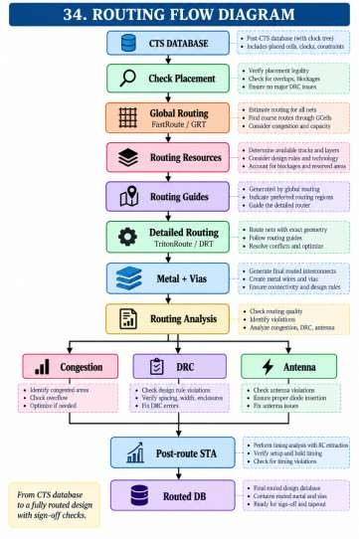
- ROUTING FLOW DIAGRAM

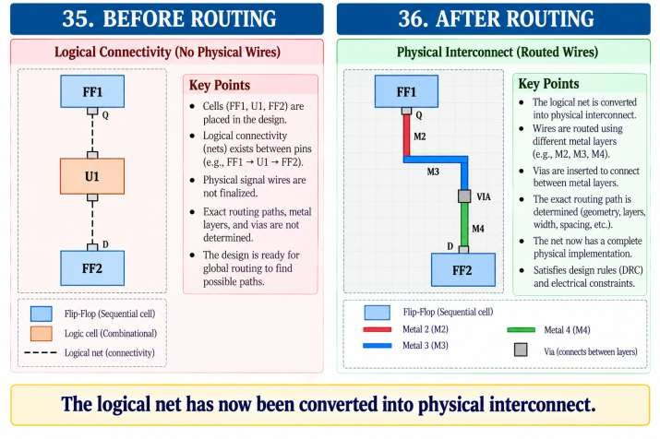

- ROUTING CONGESTION ANALYSIS
Suppose:
Routing demand = 90 tracks Routing capacity = 100 tracks Then:

𝐶𝑜𝑛𝑔𝑒𝑠𝑡𝑖𝑜𝑛 =

90

100

= 0.9

or:
90%
If:
Demand = 120
Capacity = 100 then:

𝐶𝑜𝑛𝑔𝑒𝑠𝑡𝑖𝑜𝑛 = 1.2

or:
120%
This indicates an overflow condition.

- ROUTING OVERFLOW
Routing overflow represents routing demand that cannot currently be accommodated by available routing capacity.
Conceptually:
Demand < Capacity
│
▼
Routable

Demand > Capacity
│
▼
Overflow
│
▼
Congestion / Routing Failure

The goal is generally to achieve zero overflow or an acceptable routing solution according to the design requirements.
- ROUTING AND TIMING
Routing directly affects timing.
Placement
│
▼
Estimated wirelength
│
▼
Routing
│
▼
Actual wire parasitics
│
▼
RC Extraction
│
▼
SPEF
│
▼
STA
Longer wires generally increase:
- Resistance
- Capacitance
- Propagation delay
Therefore, routing is a critical part of timing closure.

- ROUTING AND POWER
Interconnect capacitance contributes to dynamic power:
𝑃𝑑𝑦𝑛𝑎𝑚𝑖𝑐 = 𝛼𝐶𝑉2𝑓

Routing can increase capacitance due to:
  - Long wires
  - Large coupling capacitance
  - Multiple vias
  - Large metal structures
Therefore, routing optimization also contributes to power optimization.
- OBSERVATION TABLE

S.No. | Parameter | Observation
1 | Design Name
2 | OpenROAD Version
3 | Number of Nets
4 | Routing Layers
5 | Global Routing Status
6 | Routing Overflow
7 | Horizontal Overflow
8 | Vertical Overflow
9 | Total Wirelength
10 | Number of Vias
11 | Routing DRC Violations
12 | Antenna Violations
13 | Setup WNS
14 | Setup TNS
15 | Hold WNS
16 | Hold TNS
17 | Final Routing Status | PASS / FAIL

- ANALYSIS

- EXPECTED OUTPUT

- IMPORTANT OPENROAD COMMANDS

Command | Purpose
global_route | Perform global routing
write_guides | Write global-routing guides
detailed_route | Perform detailed routing using TritonRoute-based DRT
check_antennas | Check antenna violations
report_checks | Perform timing analysis
check_placement | Check placement legality
write_db | Save ODB database
write_def | Save DEF
gui::show | Open design GUI
help global_route | Show global-routing options
help detailed_route | Show detailed-routing options

- RESULT

- CONCLUSION

EXPERIMENT–12
Do IR Drop Analysis Using PDNSim Contact Hours: 2 Hours
- AIM
To study and perform IR drop analysis using PDNSim in OpenROAD, analyze the quality of the power distribution
network, identify voltage-drop hotspots, and understand the effects of power-grid resistance and current demand on chip reliability.
Important technical note: In current OpenROAD releases, the PDNSim functionality is provided through the psm
module. The main analysis command is analyze_power_grid. The syllabus uses the name PDNSim, which is the name of the underlying power-grid analysis capability.

- OBJECTIVES
After completing this experiment, the student should be able to:
- Understand the concept of IR drop.
- Understand the purpose of PDNSim.
- Understand the power distribution network (PDN).
- Analyze:
  - Static IR drop
  - Dynamic IR drop concept
  - Voltage distribution
  - Current density
  - Power-grid resistance
- Perform power-grid analysis using OpenROAD.
- Identify maximum voltage-drop locations.
- Analyze worst-case IR drop.
- Understand the relationship between:
  - Resistance
  - Current
  - Voltage drop
- Understand the impact of IR drop on timing and circuit reliability.
- Generate and interpret an IR-drop report

- SOFTWARE / TOOLS REQUIRED

S.No. | Software / File | Purpose
1  2  3  4  5 | Linux / Ubuntu | Operating environment
1  2  3  4  5 | OpenROAD | Physical design implementation
1  2  3  4  5 | PDNSim | Power-grid analysis
1  2  3  4  5 | OpenDB | Design database
1  2  3  4  5 | LEF | Technology/physical information

S.No. 6  7  8  9  10 | Software / File | Purpose
S.No. 6  7  8  9  10 | Liberty .lib | Cell information
S.No. 6  7  8  9  10 | DEF | Physical design information
S.No. 6  7  8  9  10 | ODB | OpenROAD database
S.No. 6  7  8  9  10 | PDN configuration | Power-grid definition
S.No. 6  7  8  9  10 | Power/ground connectivity | Supply-network analysis

- THEORY
  - What is IR Drop?
IR drop is the voltage drop caused by current flowing through the resistance of the power distribution network. It is represented by:
𝑉𝑑𝑟𝑜𝑝 = 𝐼 × 𝑅

where:
    - 𝑉𝑑𝑟𝑜𝑝= voltage drop
    - 𝐼= current flowing through the power network
    - 𝑅= resistance of the power network For example:
Current = 0.1 A Resistance = 0.5 Ω

Vdrop = I × R
= 0.1 × 0.5
= 0.05 V
Therefore:
IR Drop = 50 mV

- WHY IR DROP ANALYSIS IS REQUIRED
A standard cell may require a supply voltage such as: VDD = 1.0 V
Due to resistance in the power network, the cell may receive: VDD at source = 1.0 V

VDD at cell = 0.92 V Therefore:

𝑉𝑑𝑟𝑜𝑝 = 1.0 − 0.92
𝑉𝑑𝑟𝑜𝑝 = 0.08𝑉

or:
80 mV
Excessive IR drop can cause:
- Increased cell delay
- Setup timing violations

- Incorrect circuit operation
- Reduced noise margin
- Electromigration concerns
- Reliability problems

- POWER DISTRIBUTION NETWORK
The Power Distribution Network (PDN) distributes power from the power source to standard cells and macros. A simplified PDN is:
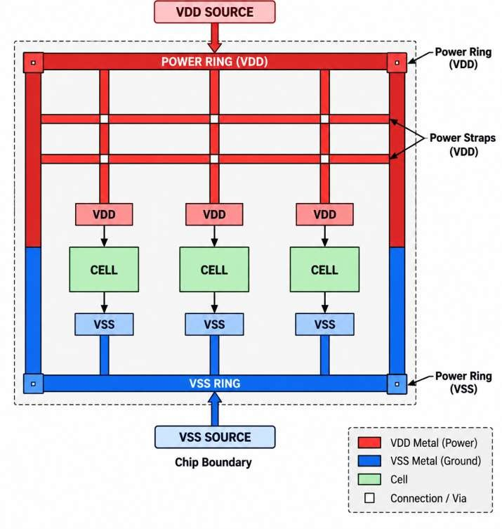

The PDN typically consists of:
- Power rings
- Power straps
- Standard-cell power rails
- Vias
- Power/ground connections

- VDD AND VSS

VDD
VDD is the positive power supply.
VSS
VSS is the ground/reference supply. Typical connection:

VDD
│
▼
Standard Cell
│
▼
VSS

The PDN must provide low-resistance paths for both power and ground.
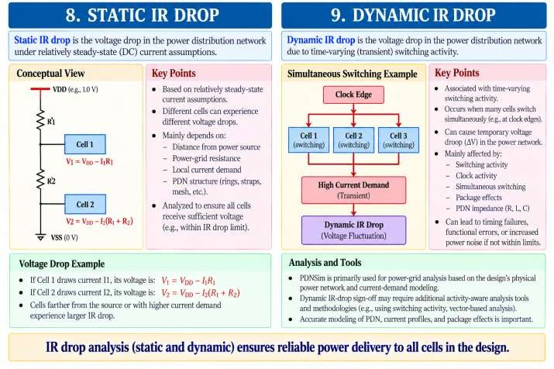

- STATIC IR DROP
Static IR drop is analyzed using relatively steady-state current assumptions. Conceptually:
Different cells can experience different voltage drops because of:
- Distance from power source
- Power-grid resistance
- Local current demand
- PDN structure

- DYNAMIC IR DROP
Dynamic IR drop is associated with time-varying switching activity. Dynamic IR drop can be affected by:
- Switching activity
- Clock activity
- Simultaneous switching
- Package effects
- PDN impedance
PDNSim is primarily used for power-grid analysis based on the design's physical power network and current-demand modeling; dynamic IR-drop sign-off may require additional activity-aware analysis tools and methodologies.

- EFFECT OF RESISTANCE
From:

𝑉 = 𝐼𝑅

If resistance increases:
𝑅 ↑⇒ 𝑉𝑑𝑟𝑜𝑝 ↑

Therefore, a weak power grid can produce significant voltage drop. Example:
Case 1:
I = 0.1 A R = 0.1 Ω

Vdrop = 10 mV

Case 2:
I = 0.1 A R = 0.5 Ω

Vdrop = 50 mV
Therefore, reducing PDN resistance helps reduce IR drop.

- EFFECT OF CURRENT
For a fixed resistance:
𝐼 ↑⇒ 𝑉𝑑𝑟𝑜𝑝 ↑

Example:
R = 0.5 Ω

I = 0.1 A → Vdrop = 50 mV
I = 0.2 A → Vdrop = 100 mV
High-current regions are therefore more likely to become IR-drop hotspots.

- IR DROP HOTSPOT
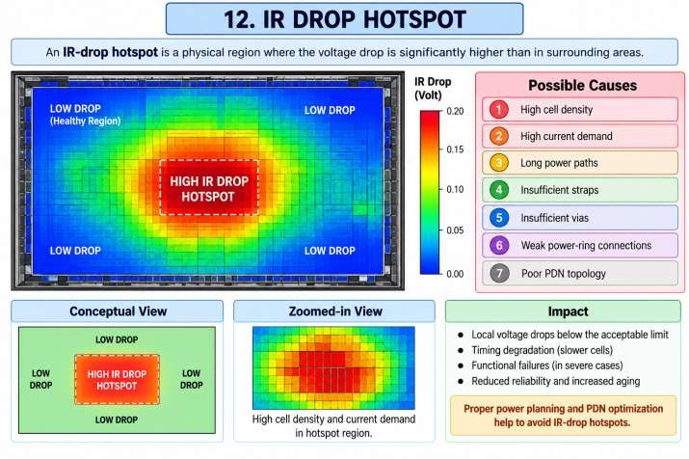

Possible causes:
- High cell density
- High current demand
- Long power paths
- Insufficient straps
- Insufficient vias
- Weak power-ring connections
- Poor PDN topology

- PDNSIM
PDNSim is OpenROAD's power-grid analysis capability used to analyze voltage drops and related power-grid characteristics.
In current OpenROAD:
PDNSim
│
▼
OpenROAD PSM module
│
▼
analyze_power_grid
The analysis uses the physical power network represented in the OpenROAD database.
- PDNSIM INPUTS
A typical PDNSim analysis requires:
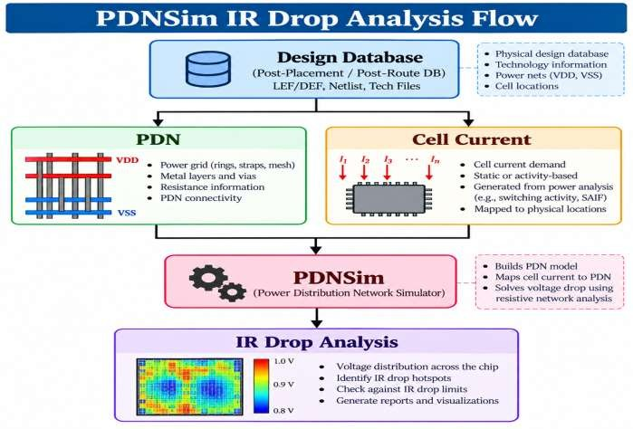

The database should contain:
- Power network
- Ground network
- Standard-cell locations
- Power/ground connectivity

- PDN geometry
- Relevant physical information
- ROLE OF PDNGEN AND PDNSIM
PDNGEN and PDNSim have different purposes.
PDNGEN
Creates the power distribution network.

PDNSim
Analyzes the generated power network.
PDNGEN
│
▼ Power Rings Power Straps Power Rails
Vias

Therefore:
PDN
│
▼
PDNSim
│
▼
Voltage Drop Current Resistance IR Hotspots

PDNGEN
│
▼
Generate Power Grid
│
▼
Physical PDN
│
▼
PDNSim
│
▼
IR Drop Analysis

- PROCEDURE
Step 1 – Check OpenROAD Installation
Run:
- openroad -version Start OpenROAD:
- openroad Check the version:
- version
- STEP 2 – Check PDNSim Commands
Inside OpenROAD:
- help analyze_power_grid You can also inspect the module:
- help
The exact options should be checked against the installed OpenROAD version.
- STEP 3 – Create Experiment Directory
- mkdir -p ~/openroad_exp12
- cd ~/openroad_exp12
- STEP 4 – Load the Design Database
For a routed design, load:
- read_db routed.odb
If your experiment is intended to analyze the PDN before routing, use the appropriate PDN database instead:
- read_db pdn.odb
For a post-routing analysis, the routed database is generally more representative.
- STEP 5 – Check the Design
Run:
- report_design_area Then:
- check_placement
Make sure the physical design is loaded correctly.

- STEP 6 – Inspect POWER/GROUND NETWORK
The design should contain the appropriate power and ground connections. Typical power nets are:
- VDD
- VSS
Check the actual power-net names in your design because they may be technology/design dependent.
- STEP 7 – Run Basic Power-Grid Analysis
Run:
- analyze_power_grid
PDNSim analyzes the power network and estimates voltage drops based on the modeled power-grid network and cell-current demands.
- STEP 8 – Generate a Report
A representative analysis can specify an output file:
- analyze_power_grid -outfile ir_drop.rpt Check the supported options first:
- help analyze_power_grid Then inspect:
- gvim ir_drop.rpt
or:
- cat ir_drop.rpt

- STEP 9 – Analyze Worst IR Drop
The report should be examined for quantities such as:
- Worst voltage drop
- Worst IR drop
- Power-grid current
- Voltage at nodes
- Power-grid connectivity Record the worst-case result. Example:
Supply Voltage = 1.00 V Worst Voltage = 0.94 V Maximum IR Drop = 0.06 V Therefore:
𝐼𝑅 𝐷𝑟𝑜𝑝 = 1.00 − 0.94
𝐼𝑅 𝐷𝑟𝑜𝑝 = 0.06𝑉

or:

60 mV
- STEP 10 – Inspect IR Drop in the GUI
Launch:
- gui::show
Inspect the physical design for power-grid structures and IR-drop-related information available in the GUI/version being used.
Look for:
- Power rings
- Power straps
- Standard-cell rows
- High-current regions
- IR-drop hotspots

- STEP 11 – Analyze Power-Grid Connectivity
A reliable power grid requires good connectivity between:
Power Ring
│
▼
Power Straps
│
▼
Standard-cell Rails
│
▼
Cell VDD/VSS Pins
Poor connectivity can increase resistance and produce larger voltage drops.
- STEP 12 – Compare Different PDN Configurations
For educational analysis, modify the PDN and compare the results.
Case 1 – Lower Strap Density

Case 2 – Higher Strap Density
Wide spacing between straps
↓
Higher effective resistance
↓
Higher IR drop

More straps
↓
Lower effective resistance
↓
Lower IR drop
This demonstrates the relationship between PDN design and voltage stability

- STEP 13 – Analyze Power Ring Effect
A stronger power ring can provide better current distribution.
Actual improvement depends on the complete PDN topology and current distribution.
- STEP 14 – Save the Analysis Database
The IR-drop analysis itself does not necessarily require creating a new physical database, but after completing the experiment you may save the analyzed design state:
- write_db ir_drop_analysis.odb

- COMPLETE REPRESENTATIVE SCRIPT
Create:
- gvim exp12_ir_drop.tcl Example:
read_db routed.odb report_design_area check_placement
analyze_power_grid -outfile ir_drop.rpt write_db ir_drop_analysis.odb
Run:
- openroad exp12_ir_drop.tcl
Note: The exact analyze_power_grid options depend on the OpenROAD version and design setup. Always check: help analyze_power_grid

- IR DROP ANALYSIS FLOW
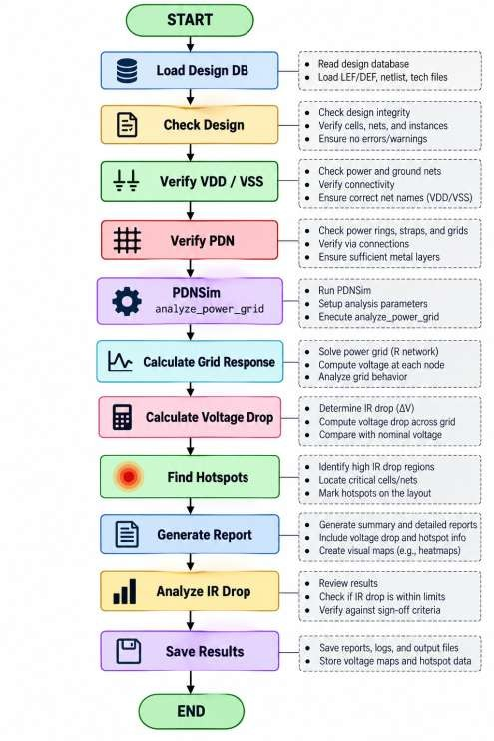

- IR DROP CALCULATION EXAMPLE
Consider:
Supply Voltage = 1.0 V Current = 0.2 A
Power-grid resistance = 0.25 Ω

Using:

𝑉𝑑𝑟𝑜𝑝 = 𝐼𝑅
𝑉𝑑𝑟𝑜𝑝 = 0.2 × 0.25
𝑉𝑑𝑟𝑜𝑝 = 0.05𝑉

Therefore:
IR Drop = 50 mV
Voltage delivered to the load:

𝑉𝑙𝑜𝑎𝑑 = 1.0 − 0.05
𝑉𝑙𝑜𝑎𝑑 = 0.95𝑉

- EFFECT OF IR DROP ON CELL DELAY
Suppose a standard cell is characterized for:
  - VDD = 1.0 V
But due to IR drop it receives:
  - VDD = 0.90 V
The reduced supply voltage can cause the cell to switch more slowly.
- IR DROP AND TIMING
IR drop can affect timing closure.

Therefore:
Power Grid
│
▼
IR Drop
│
▼
Reduced Supply Voltage
│
▼
Increased Cell Delay
│
▼
Path Delay Increase
│
▼
Slack Reduction
│
▼
Possible Timing Violation

Good PDN → Low IR Drop → Better Timing Robustness

- IR DROP AND ELECTROMIGRATION
IR drop and electromigration (EM) are related to current flow through the power network, but they are different failure mechanisms.
IR Drop
Concern:
  - Voltage loss Electromigration Concern:
Excessive current density
↓
Metal atom movement
↓
Reliability degradation
Therefore, both IR drop and EM should be considered during power-integrity analysis.

- STATIC VS DYNAMIC IR DROP

Parameter | Static IR Drop | Dynamic IR Drop
Current | Relatively steady | Time-varying
Main cause | Average/steady current | Switching activity
Analysis | DC/resistive network behavior | Activity-dependent behavior
Hotspots | High-current regions | Simultaneous switching regions
Impact | Voltage degradation | Transient voltage droop
Typical concern | Power-grid strength | Switching-induced supply noise

- METHODS TO REDUCE IR DROP

If IR drop is too high, possible PDN improvements include:
- Increase Power-Strap Width

- Reduce Strap Pitch
More straps can provide additional current paths.
- Add Additional Metal Layers
Wider strap
↓
Lower resistance
↓
Lower IR drop

Additional high-level metal resources can improve power distribution.

- Increase Via Density
More parallel vias can reduce resistance at layer transitions.
- Improve Power-Ring Design
A stronger ring can distribute current more effectively.
- Reduce Local Current Demand
Power optimization can reduce current demand and therefore reduce IR drop.

- OBSERVATION TABLE

S.No. | Parameter | Observation
1 | Design Name
2 | OpenROAD Version
3 | Power Net
4 | Ground Net
5 | Supply Voltage
6 | PDN Type
7 | Power Ring
8 | Power Straps
9 | Maximum Current
10 | Worst Voltage
11 | Maximum IR Drop
12 | IR Drop Percentage
13 | Hotspot Location
14 | Analysis Status | PASS / FAIL

- IR DROP PERCENTAGE
IR drop can be expressed as a percentage of the supply voltage:
𝑉𝑑𝑟𝑜𝑝
𝐼𝑅 𝐷𝑟𝑜𝑝% =
𝑉𝐷𝐷

× 100

Example:
VDD = 1.0 V
Vdrop = 0.05 V

Then:

𝐼𝑅 𝐷𝑟𝑜𝑝% =
= 5%

0.05

1.0

× 100

Therefore:
IR Drop = 5%
Whether this is acceptable depends on the technology and design sign-off requirements.

- ANALYSIS

- EXPECTED OUTPUT

- IMPORTANT OPENROAD COMMANDS

Command | Purpose
read_db | Read OpenROAD database
report_design_area | Report design area
check_placement | Check placement
analyze_power_grid | Perform PDNSim power-grid analysis
write_db | Save OpenROAD database
gui::show | Open GUI
help analyze_power_grid | Display PDNSim command options

- PDNGEN VS PDNSIM

Feature | PDNGEN | PDNSim
Main purpose | Generate power grid | Analyze power grid
Operation | Physical implementation | Power-integrity analysis
Creates rings | Yes | No
Creates straps | Yes | No
Adds PDN connections | Yes | Analyzes them
Calculates IR drop | No | Yes
Identifies voltage hotspots | No | Yes
Current OpenROAD module | pdn | psm

- RESULT

- CONCLUSION

EXPERIMENT–13
Perform Parasitic Extraction Analysis Using OpenRCX Contact Hours: 2 Hours

- AIM
To study and perform parasitic extraction using OpenRCX in OpenROAD, extract the resistance and capacitance of routed interconnects, generate a SPEF (Standard Parasitic Exchange Format) file, and analyze the effect of extracted parasitics on post-route timing.

- OBJECTIVES
After completing this experiment, the student should be able to:
- Understand the concept of parasitic extraction.
- Understand the need for post-route RC extraction.
- Study the working principle of OpenRCX.
- Understand:
  - Resistance
  - Capacitance
  - Coupling capacitance
  - RC networks
- Generate extraction rules for a technology.
- Load a routed design into OpenROAD.
- Perform parasitic extraction using OpenRCX.
- Generate a SPEF file.
- Read extracted parasitics into OpenSTA/OpenROAD.
- Compare pre-route and post-route timing.
- Understand how interconnect parasitics affect:
- Delay
- Slew
- Setup timing
- Hold timing
- Power

- SOFTWARE / TOOLS REQUIRED

S.No. | Software / File | Purpose
1  2  3  4  5  6  7 | Linux / Ubuntu | Operating environment
1  2  3  4  5  6  7 | OpenROAD | Physical design environment
1  2  3  4  5  6  7 | OpenRCX | Parasitic extraction
1  2  3  4  5  6  7 | OpenSTA | Post-route timing analysis
1  2  3  4  5  6  7 | OpenDB | Design database
1  2  3  4  5  6  7 | LEF | Physical technology information
1  2  3  4  5  6  7 | Liberty .lib | Cell timing information

S.No.  8  9  10 | Software / File | Purpose
S.No.  8  9  10 | DEF / ODB | Routed physical design
S.No.  8  9  10 | RCX extraction rules | Resistance/capacitance extraction
S.No.  8  9  10 | SPEF | Extracted parasitic information

- THEORY
  - What are Parasitics?
In an ideal digital circuit, a wire would have zero resistance and zero capacitance. In a real ASIC, every physical interconnect has electrical properties.
A routed wire can be modeled approximately as:
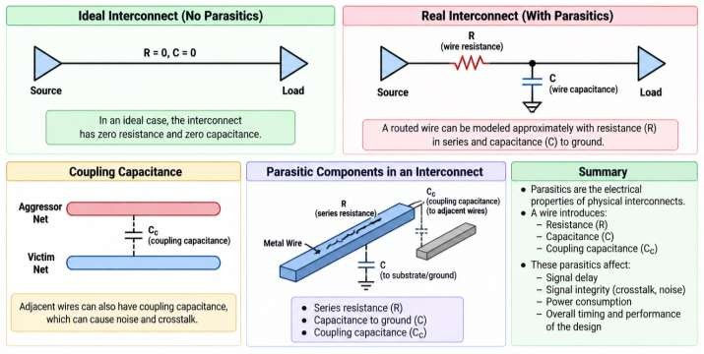
The wire therefore introduces:
    - Resistance 𝑅
    - Capacitance 𝐶
    - Coupling capacitance These are called parasitics.

- WHY PARASITIC EXTRACTION IS REQUIRED
Before routing, wire characteristics are estimated.
After routing, the actual physical geometry is known.
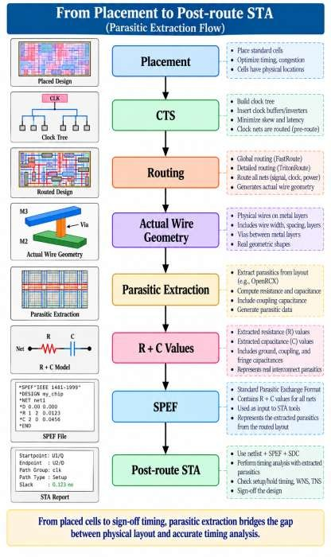

Post-route parasitics provide a more realistic representation of the physical interconnect.

- WHAT IS OpenRCX?
In the current OpenROAD architecture:
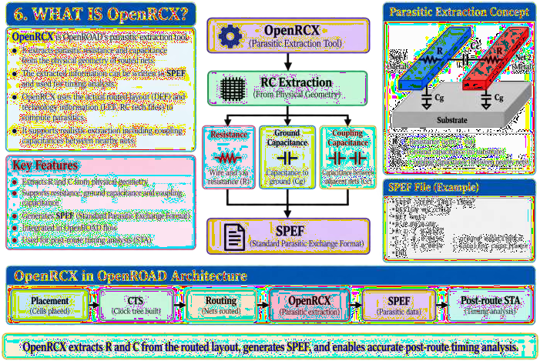

The current OpenROAD extraction module is rcx.
- WHAT IS RC EXTRACTION?
RC extraction determines the electrical characteristics of physical interconnects. For each routed net, extraction can determine:
Wire length
│
├── Resistance
│
├── Ground capacitance
│
└── Coupling capacitance
These values are required for accurate timing analysis.

- RESISTANCE
Resistance opposes current flow.
The resistance of a uniform metal wire can be approximated as:
𝐿
𝑅 = 𝜌
𝐴

where:
- 𝑅= resistance
- 𝜌= resistivity
- 𝐿= wire length
- 𝐴= cross-sectional area

Therefore:
Wire length ↑
↓ Resistance ↑
and:
Wire width ↑
↓ Resistance ↓

- CAPACITANCE

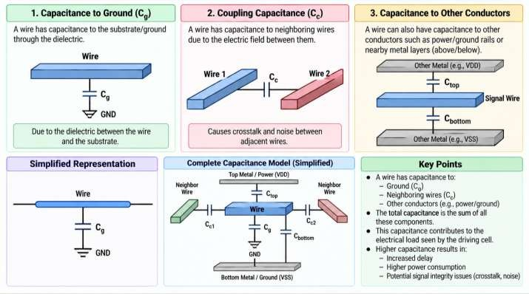
A wire has capacitance to:
- Ground
- Neighboring wires
- Other conductors
The capacitance contributes to the electrical load seen by the driving cell.
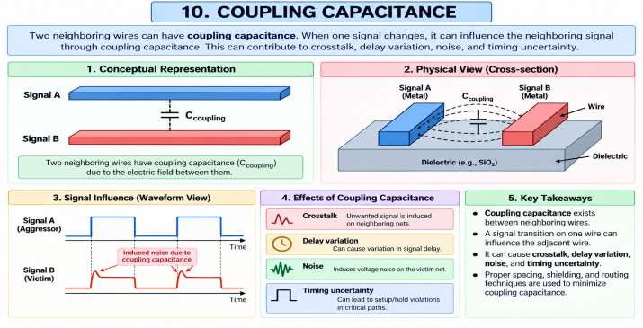

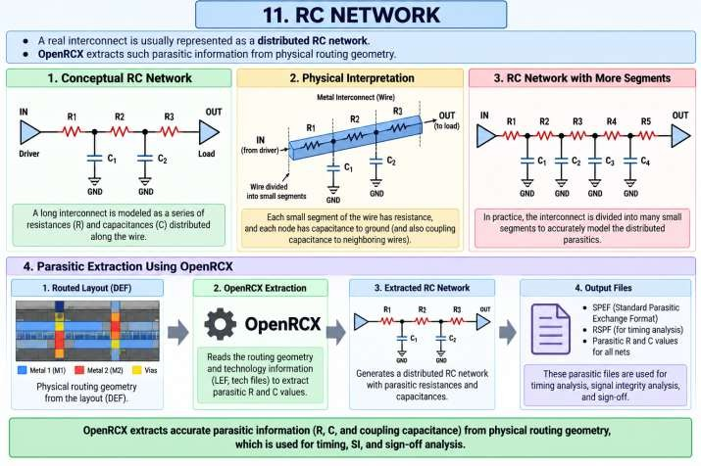

- EFFECT OF WIRE LENGTH
As wire length increases:

𝑅 ∝ 𝐿

and approximately:
𝐶 ∝ 𝐿

Therefore:

Long Wire
│
├── Higher R
├── Higher C
│
▼
Higher RC delay

- RC DELAY
A simplified RC delay relationship is:

𝑡𝑑 ≈ 𝑅𝐶

For example:
R = 100 Ω C = 20 fF

t ≈ RC
= 100 × 20 fF
= 2 ps
Actual interconnect delay is more complex because real nets have distributed resistance, capacitance, driver characteristics, loads, and coupling effects.

- OPENRCX INPUTS
A typical OpenRCX extraction flow requires:
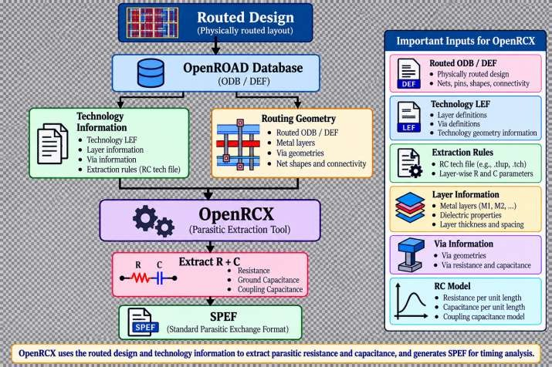
- EXTRACTION RULES
OpenRCX uses technology-specific extraction rules to determine resistance and capacitance. These rules describe characteristics such as:
- Metal layers
- Metal widths
- Metal spacing
- Dielectric properties
- Resistance values

- Capacitance behavior
- Via characteristics
A typical extraction-rules file may be technology-specific. For example:
- rcx_rules.txt
The exact format and contents depend on the technology/PDK.
- SPEF
SPEF stands for:
Standard Parasitic Exchange Format
It is a standard format used to represent extracted parasitic information. A SPEF file can contain:
- Nets
- Nodes
- Resistance
- Ground capacitance
- Coupling capacitance
The exact contents depend on the extracted design and technology.
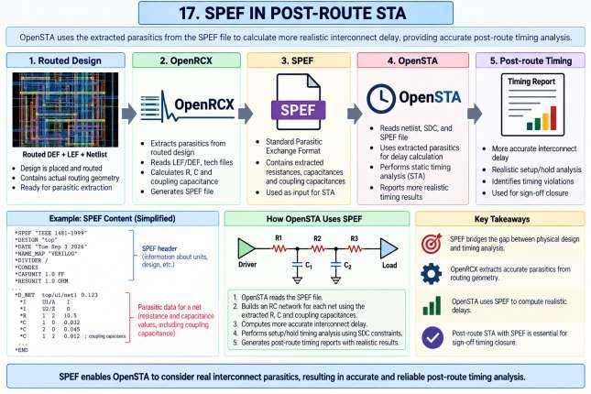

- PROCEDURE
Step 1 – Check OpenROAD Version
Run:
  - openroad -version Start OpenROAD:
  - openroad Check:
  - version

- STEP 2 – Check OpenRCX Commands
Inside OpenROAD:
  - help set_extraction_rules_file Check the extraction command:
  - help extract_parasitics

Check SPEF output:
  - help write_spef
The exact options should always be checked against the installed OpenROAD version.
- STEP 3 – Create Experiment Directory
  - mkdir -p ~/openroad_exp13
  - cd ~/openroad_exp13
- STEP 4 – Obtain the Routed Design
Use the routed database generated in Experiment-11:
  - routed.odb
The design should already contain:
  - Floorplan
  - Power grid
  - Placement
  - CTS
  - Signal routing

- STEP 5 – Load Routed Database
Start OpenROAD:
  - openroad Load the database:
  - read_db routed.odb Check:
  - report_design_area and:
  - check_placement

- STEP 6 – Inspect Routed Design
Launch the GUI:
  - gui::show Inspect:
  - Metal layers
  - Vias
  - Signal nets
  - Clock network
  - Power network
  - Routing congestion
The design should contain actual physical routing before parasitic extraction.

- STEP 7 – Load Extraction Rules
OpenRCX requires technology-specific extraction rules. Representative command:
  - set_extraction_rules_file <rcx_rules_file> For example:
  - set_extraction_rules_file rcx_rules.txt
The actual file name and location depend on the technology being used.
- STEP 8 – Define Process Corner
OpenRCX can use process-corner information for extraction. A representative command is:
  - define_process_corner -ext_model_index 0 X
The exact syntax and process-corner setup depend on the extraction-rule file and OpenRCX version. Use:
  - help define_process_corner to check the supported syntax.

- STEP 9 – Perform Parasitic Extraction
Run:
  - extract_parasitics -ext_model_file <rcx_rules_file>
Depending on the extraction setup, the extraction command may instead use the extraction rules configured previously. Always verify:
  - help extract_parasitics

- STEP 10 – Write SPEF
After extraction:
  - write_spef design.spef The resulting file is:
  - design.spef Check that it exists:
  - ls -lh design.spef

- STEP 11 – Inspect SPEF
Use:
  - gvim design.spef
or:
  - head -50 design.spef
Look for sections describing:
  - Design
  - Ports
  - Nets
  - Resistance
  - Capacitance
  - Coupling capacitance

- STEP 12 – Read SPEF for STA
The extracted SPEF can be read into the timing-analysis environment. Representative command:
  - read_spef design.spef

Then run:
  - report_checks -path_delay max and:
  - report_checks -path_delay min

- STEP 13 – Analyze Post-Route Timing
Record:
  - Setup WNS
  - Setup TNS
  - Hold WNS
  - Hold TNS
  - Critical Path
- STEP 14 – Analyze Critical Nets
Identify timing-critical nets and examine:
  - Wire length
  - Metal layers
  - Number of vias
  - Resistance
  - Capacitance
  - Coupling capacitance

- COMPLETE REPRESENTATIVE SCRIPT
Create:
  - gvim exp13_rcx.tcl Representative flow:
read_db routed.odb report_design_area check_placement
set_extraction_rules_file <rcx_rules_file> define_process_corner -ext_model_index 0 X
extract_parasitics -ext_model_file <rcx_rules_file>

write_spef design.spef write_db rcx.odb
Run:
  - openroad exp13_rcx.tcl
Important: The exact extraction-rule and process-corner syntax is technology-dependent. Verify the commands in your installed OpenROAD version using help.
- ALTERNATIVE POST-ROUTE STA FLOW
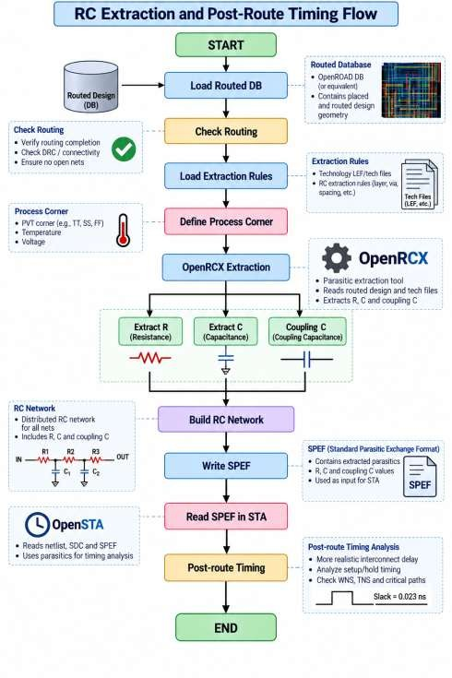

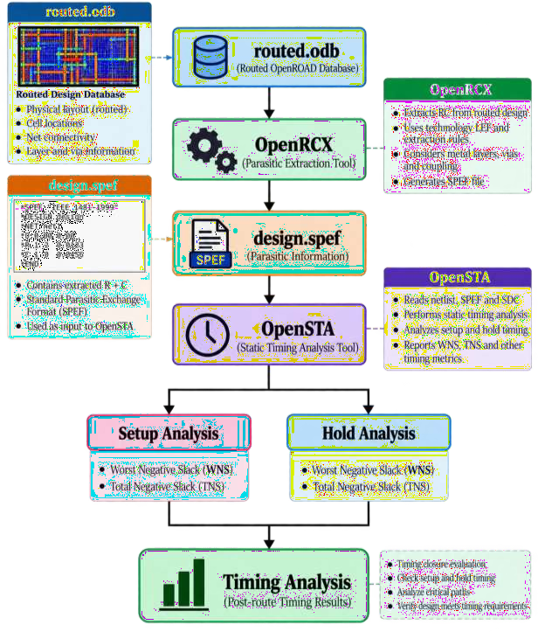
- PARASITIC EXTRACTION FLOW

- RC EXTRACTION EXAMPLE
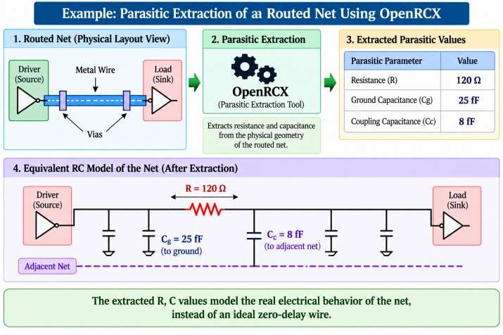
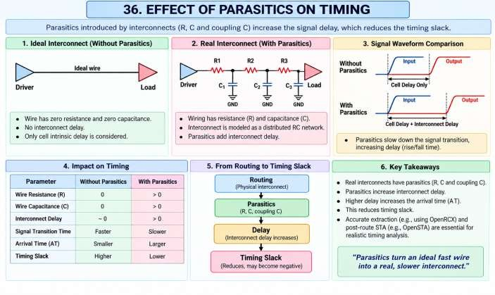

- PRE-ROUTE VS POST-ROUTE TIMING

Parameter | Pre-route | Post-route
Wire information | Estimated | Extracted
Resistance | Estimated/model-based | Extracted
Capacitance | Estimated/model-based | Extracted
Coupling | Limited/estimated | Extracted
Timing accuracy | Lower | Higher
Physical realism | Lower | Higher
Sign-off relevance | Lower | Higher

- OBSERVATION TABLE

S.No. | Parameter | Observation
1  2  3  4  5  6  7  8  9  10  11  12  13  14 | Design Name
1  2  3  4  5  6  7  8  9  10  11  12  13  14 | OpenROAD Version
1  2  3  4  5  6  7  8  9  10  11  12  13  14 | Routed Database
1  2  3  4  5  6  7  8  9  10  11  12  13  14 | Extraction Rules
1  2  3  4  5  6  7  8  9  10  11  12  13  14 | Process Corner
1  2  3  4  5  6  7  8  9  10  11  12  13  14 | Number of Nets
1  2  3  4  5  6  7  8  9  10  11  12  13  14 | Total Wirelength
1  2  3  4  5  6  7  8  9  10  11  12  13  14 | Extracted Resistance
1  2  3  4  5  6  7  8  9  10  11  12  13  14 | Ground Capacitance
1  2  3  4  5  6  7  8  9  10  11  12  13  14 | Coupling Capacitance
1  2  3  4  5  6  7  8  9  10  11  12  13  14 | SPEF File
1  2  3  4  5  6  7  8  9  10  11  12  13  14 | Pre-route WNS
1  2  3  4  5  6  7  8  9  10  11  12  13  14 | Post-route WNS
1  2  3  4  5  6  7  8  9  10  11  12  13  14 | Pre-route TNS

S.No. | Parameter | Observation
15  16 | Post-route TNS
15  16 | Timing Status | PASS / FAIL

- ANALYSIS

- EXPECTED OUTPUT

- IMPORTANT OPENROAD COMMANDS

Command | Purpose
read_db | Read routed OpenROAD database
set_extraction_rules_file | Set RC extraction rules
define_process_corner | Define extraction process corner
extract_parasitics | Extract RC parasitics
write_spef | Write extracted parasitics to SPEF
read_spef | Read SPEF for timing analysis
report_checks | Analyze timing
write_db | Save database
gui::show | Open GUI
help extract_parasitics | Show extraction options
help write_spef | Show SPEF output options

- RESULT

- CONCLUSION

EXPERIMENT–14
Check Antenna Rules Violations Using Antenna Rule Checker and Generate a Report Contact Hours: 2 Hours

- AIM
To check antenna rule violations in a routed ASIC design using the Antenna Rule Checker in OpenROAD, analyze the violating nets and metal layers, and generate an antenna violation report.
- OBJECTIVES
After completing this experiment, the student will be able to:
- Understand the antenna effect in semiconductor fabrication.
- Understand why long metal interconnects can damage MOS gate oxide.
- Understand antenna-rule ratios used by foundries.
- Run the OpenROAD Antenna Rule Checker.
- Check antenna violations in a routed design.
- Identify violating nets and layers.
- Generate and analyze an antenna report.
- Understand common antenna-fixing techniques.
- Distinguish antenna violations from conventional DRC violations.

- SOFTWARE / TOOLS REQUIRED

S. No. | Software / Tool | Purpose
1  2  3  4  5  6  7  8  9  10 | Linux / Ubuntu | Operating environment
1  2  3  4  5  6  7  8  9  10 | OpenROAD | Physical design and antenna analysis
1  2  3  4  5  6  7  8  9  10 | Antenna Rule Checker | Detection of antenna violations
1  2  3  4  5  6  7  8  9  10 | OpenDB | Design database
1  2  3  4  5  6  7  8  9  10 | Yosys | RTL synthesis
1  2  3  4  5  6  7  8  9  10 | OpenSTA | Timing analysis
1  2  3  4  5  6  7  8  9  10 | LEF | Physical technology/cell information
1  2  3  4  5  6  7  8  9  10 | Liberty .lib | Cell timing information
1  2  3  4  5  6  7  8  9  10 | DEF / ODB | Placed and routed design
1  2  3  4  5  6  7  8  9  10 | PDK antenna rules | Technology-specific antenna limits

- THEORY
  - What is the Antenna Effect?
During semiconductor manufacturing, metal layers are fabricated through several plasma-based processing steps. A long metal wire connected to a transistor gate can collect electrical charge during fabrication.
If the accumulated charge has no safe discharge path, it can flow through the transistor gate and damage the thin gate oxide.
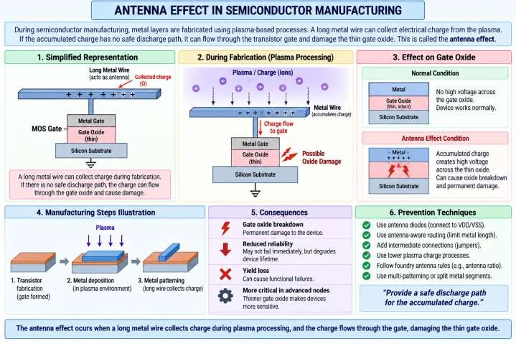
This phenomenon is called the antenna effect. n

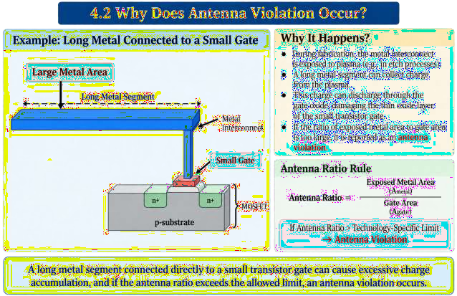

  - Antenna Ratio

A simplified antenna ratio can be represented as:
𝐴𝑛𝑡𝑒𝑛𝑛𝑎 𝑅𝑎𝑡𝑖𝑜 =

𝑀𝑒𝑡𝑎𝑙 𝐴𝑟𝑒𝑎

𝐺𝑎𝑡𝑒 𝐴𝑟𝑒𝑎

For example, suppose: Metal area = 1000 µm² Gate area = 10 µm²
Then:

𝐴𝑛𝑡𝑒𝑛𝑛𝑎 𝑅𝑎𝑡𝑖𝑜 =

1000

10

= 100

If the technology permits a maximum ratio of 80, the net violates the antenna rule.
Important: Actual antenna rules are technology/PDK dependent. Foundries may define different area, sidewall, perimeter, partial-area, and layer-specific rules.

  - Antenna Rules
A foundry provides antenna rules that specify the maximum permitted amount of conductor connected to sensitive transistor terminals during manufacturing.
Rules can depend on:
    - Metal layer
    - Metal area
    - Metal perimeter
    - Gate area

    - Sidewall area
    - Via contribution
    - Layer combination
    - Process step
    - Diode protection

  - Antenna Violation
An antenna violation occurs when the calculated antenna value exceeds the allowed value specified by the technology rules.
Example:
Allowed Ratio = 80 Actual Ratio = 125

  - Antenna Rule Checker in OpenROAD
125 > 80
↓
ANTENNA VIOLATION

OpenROAD contains an Antenna Rule Checker that analyzes the routed design against the antenna rules available for the technology.
The current OpenROAD antenna module is associated with the ant module, and the main command is:
    - check_antennas
Useful commands can be inspected using:
    - help check_antennas
The checker can be used after routing when the design contains actual routed metal and vias.

  - Position of Antenna Checking in ASIC Flow
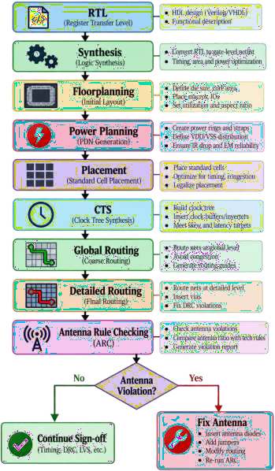

  - Why Antenna Checking is Performed After Routing Antenna rules depend strongly on the physical interconnect. Before routing:
Cell ───── Cell
There is no complete physical metal structure to analyze. After routing:
Cell ──M1──Via──M2────────Via──M3──Cell

The checker can analyze:
    - Metal area
    - Metal perimeter
    - Vias
    - Connected gate area
    - Layer information
    - Net connectivity
Therefore, antenna checking is normally performed on the routed design.
  - Antenna Violation Example
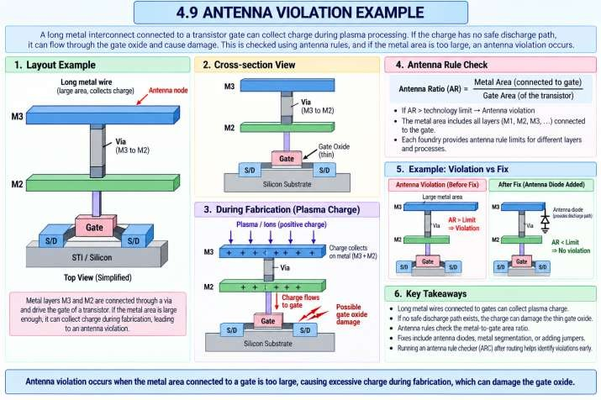
Suppose:

Metal Area = 900 µm² Gate Area = 5 µm²
Then:

𝐴𝑛𝑡𝑒𝑛𝑛𝑎 𝑅𝑎𝑡𝑖𝑜 =

900

5

= 180

If:
Maximum Allowed Ratio = 100 then:

Actual Ratio > Allowed Ratio
↓ Antenna Violation

  - Common Antenna Fixing Techniques
Although this experiment focuses on checking and reporting, understanding the repair methods is important.
- Antenna Diode Insertion
A diode can provide a discharge path for accumulated charge.
- Metal Jumper
The connection can be moved to a higher metal layer through a via/jumper structure.
This can reduce the antenna contribution associated with lower layers during particular manufacturing steps.
- Routing Modification
The router may be able to modify the route to reduce the violating conductor contribution
- Reduce Metal Exposure
If possible, reducing the amount of exposed metal connected to the gate can reduce the antenna ratio.
- EXPERIMENT FLOW
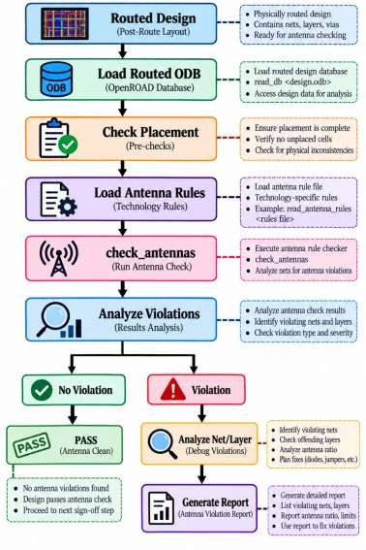

- PROCEDURE
Step 1: Check OpenROAD Installation Open a Linux terminal and execute:
  - openroad -version
Expected output will display the installed OpenROAD version.
Step 2: Create Experiment Directory
  - mkdir -p ~/openroad_exp14
  - cd ~/openroad_exp14
Step 3: Start OpenROAD
  - openroad
You should see the OpenROAD Tcl prompt:
  - OpenROAD>
Step 4: Check Antenna Command
At the OpenROAD prompt:
  - help check_antennas
This displays the available antenna-checking options for your installed OpenROAD version.
Step 5: Load the Routed Design
Use the routed database generated in the previous experiment:
  - read_db routed.odb
Alternatively, if your routed design has another name:
  - read_db <routed_design>.odb

Step 6: Check Design Placement
Run:
  - check_placement
This verifies that the physical placement is valid before proceeding with analysis.

Step 7: Check Antenna Violations
Run:
  - check_antennas
The checker analyzes the routed design for antenna-rule violations.

Step 8: Run a Detailed Antenna Check
For additional information, use:
  - check_antennas -verbose
The exact available options can vary with the OpenROAD version, so always verify using:
  - help check_antennas
Step 9: Check a Specific Net
If the installed version supports the -net option, a particular net can be checked using:
  - check_antennas -net <NET_NAME>
For example:
  - check_antennas -net net_123
Use the exact net name present in your design.
- CREATE AN ANTENNA CHECK SCRIPT
Create a Tcl script:
  - gvim exp14_antenna.tcl
Enter:
  - read_db routed.odb

  - check_placement

  - check_antennas -verbose
Save and exit GVim.

- RUN THE SCRIPT
Execute:
  - openroad exp14_antenna.tcl To save the output to a report:
  - openroad exp14_antenna.tcl > antenna_report.txt

- VIEW THE REPORT
Use:
  - gvim antenna_report.txt
or:
  - cat antenna_report.txt

You can search the report for relevant terms in GVim:
  - /antenna
or:
  - /violation

- ANALYSIS OF ANTENNA REPORT
- OBSERVATION TABLE

Parameter | Observation
Design Name
OpenROAD Version
Routed Database | routed.odb
Number of Nets Checked
Number of Antenna Violations
Violating Net(s)
Violating Layer(s)
Maximum Antenna Value/Ratio
Antenna Rule Limit
Diode Protection
Report File | antenna_report.txt
Overall Status | PASS / FAIL

- ANTENNA VS DRC
Antenna checking is related to physical verification but is not exactly the same as conventional geometric DRC.

DRC | Antenna Check
Checks geometric/manufacturing rules | Checks charge-related antenna rules
Width, spacing, enclosure, etc. | Metal/gate relationship and antenna rules
Primarily geometric constraints | Connectivity + layer + technology rules
Can detect shorts/spacings | Detects potential gate-oxide damage

DRC | Antenna Check
Used throughout physical verification | Particularly important after routing

- ANTENNA VS IR DROP
These two analyses address different reliability problems.

Antenna Analysis | IR Drop Analysis
Fabrication-related reliability | Power-delivery reliability
Concerned with accumulated plasma charge | Concerned with voltage drop
Associated with gate oxide damage | Associated with insufficient supply voltage
Uses antenna rules | Uses PDN/current information
Performed using antenna checker | Performed using PDNSim/power-grid analysis

- EXPECTED OUTPUT

- RESULT

18. CONCLUSION

EXPERIMENT RTL-TO-GDSII FLOW

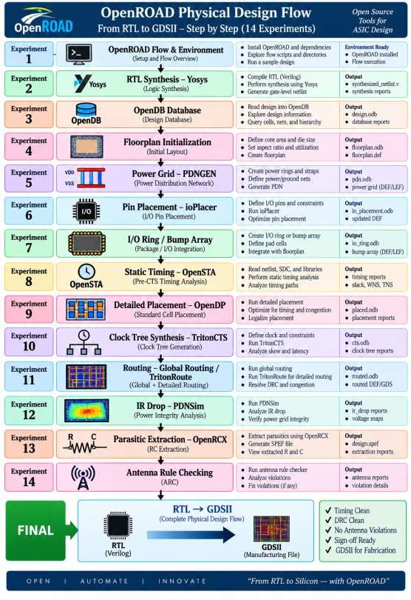

ALL THE BEST FOR EXAM AND YOUR FUTURE

KEEP WORKING HARD…..

Thank you …..

